WEEK 4 PROJECT 6

LINK: <https://drive.google.com/drive/folders/1ZoCqnFjcXktOsBGQdaf8Akmx5k8xv0-f?usp=sharing>

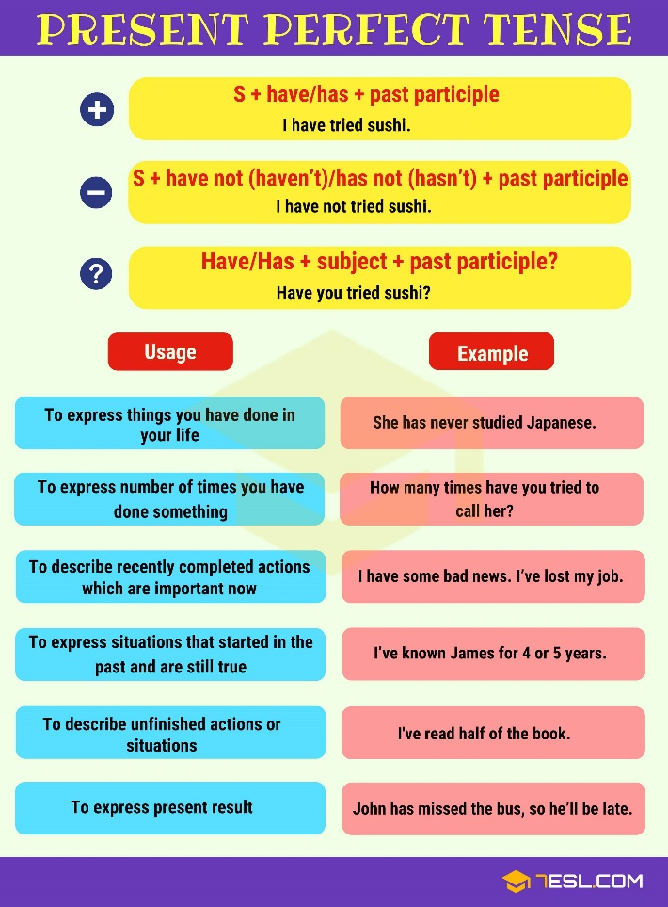

HAVE/ HAS (HE, SHE,IT)

S+HAVE/HAS+ VERB PP+COMPLEMENT

|  |  |  |  |
| --- | --- | --- | --- |
| I | have | been | in the hospital |
| You | have | watched | soccer game |
| he | has | fed | the fish |
| She | has | aten | cake. |

|  |  |  |
| --- | --- | --- |
| AFFIRMATIVE | NEGATIVE- have/ has + not | INTERROGATIVE |
| I have been in the hospital | I haven’t / have not been in the hospital | Have I been in the hospital? |
| you have watched soccer game | You haven’t watched soccer game | have you watched soccer game? |
| she has eaten cake | she hasn’t eaten cake | has she eaten cake? |
| John has seen his uncle | John hasn’t seen his uncle | has John seen his uncle? |
|  |  |  |

HOMEWORK:

Write the sentences in affirmative, negative or interrogative

|  |  |  |
| --- | --- | --- |
| affirmative | negative | interrogative |
|  | My mother hasn’t spoken to my sister |  |
| Joe has lived in London for five years. |  |  |
|  |  | Have we known each other? |
| I have learned these words easily. |  |  |
|  | Our family has lived in the north of the USA. |  |
|  |  | Has my friend Margo wrote me two letter? |
| Jason has made music for more than 25 years |  |  |
| My brother has had his new mountain bike. |  |  |
| They have played tennis. |  |  |
| We have spent a lot of money. |  |  |