PROJECT 6 WEEK 4
LINK:
https://drive.google.com/drive/folders/1Mg574Mp0ewbItDHNnDcZW-4XPH47sBWT?usp=sharing

1. CULTURE AND TRADITIONS OF ECUADOR

Match the name with the picture.
THE MAMA NEGRA | HOLY WEEK | GALAPAGOS ISLAND | CHRISTMAS | DIA DE LOS DIFUNTOS
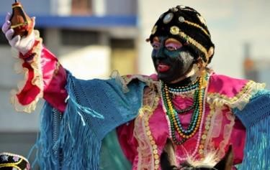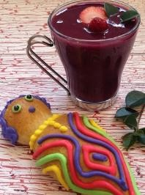 |  |  | 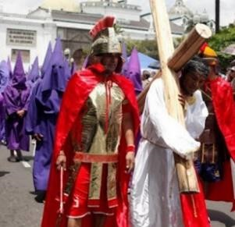
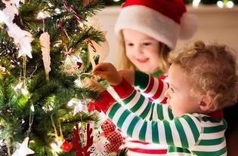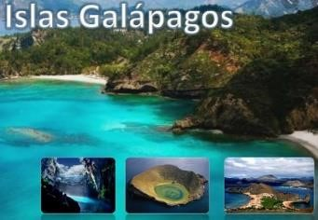

READING
CULTURE AND TRADITIONS OF ECUADOR

Ecuador is a country that has one of the most diverse collection of species of plants and animal in the world. The Andes mountains run through the country. And the Galapagos Islands. Ecuador was once part of the Inca Empire until the Spanish arrived. The Inca language of Quechua is still widely spoken in Ecuador today. Most Ecuadorians practice Catholicism and speak Spanish. Quito is the capital city.
There are certain times of the year where the traditions are celebrated. In March or April, you can come and see the eastern processions to celebrate the holy week. During these processions there are a lot of people dressed in purple costumes on the streets holding a statue of Jesus, crosses or other religious symbols.
On the 24th June, there is the celebration of the sun, which is called Inti Raymi and it takes place in the city of Otavalo.
On 2nd November takes the “Día de los difuntos”, which is celebrated in Europe and North America as All Saint´s Day. Especially to this day the Ecuadorians bake “Guaguas de pan” and cook “Colada Morada”.
In the first week of November there is also another ceremony, which is called “Mama Negra”. This special event is for the anniversary of their independency. It also symbolizes the cultures of the indigenous, the Hispanics and the Africans.
The Ecuadorians of course also celebrate Christmas. On the 15th December the families come together in the houses to have the novena. They have hot chocolate with biscuits, read poems and sing Christmas songs. On the 24th they have the traditional Christmas Eve dinner with a turkey.
At the end of the year, Ecuadorians celebrated the old year. They build figures out of paper and glue (años viejos) which they are going to burn at midnight. Like this the bad spirits can be banished and they hope the new year will be better. Additionally, there are a lot of Fireworks going on in the cities.

ACTIVITIES.
1. Circle the correct answer.

- Ecuadorians practice Catholicism / Budism and speak English/Spanish.
- processions and people dressed in purple costumes on the streets holding a statue of Jesus is to celebrate the Mama Negra / Holy week
- Ecuadorians bake “Guaguas de pan” and cook “Colada Morada” to celebrate the Inty Raymi
/ Dia de los difuntos
- Ecuadorians celebrated the old year. they burn the “año Viejo” at midnight/ noon

2. Look at the picture and complete the paragraph with the words in the box
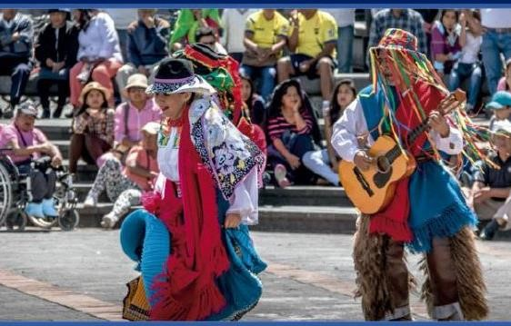


dance
-

can
-

Ecuador
-

instrument
-

guitar
.

This picture is a traditional celebration in ………………… the woman can ………………………., but she can’t play an ………………… The man …………………dance and he is playing the ………………

