Proyecto 6 semana 1
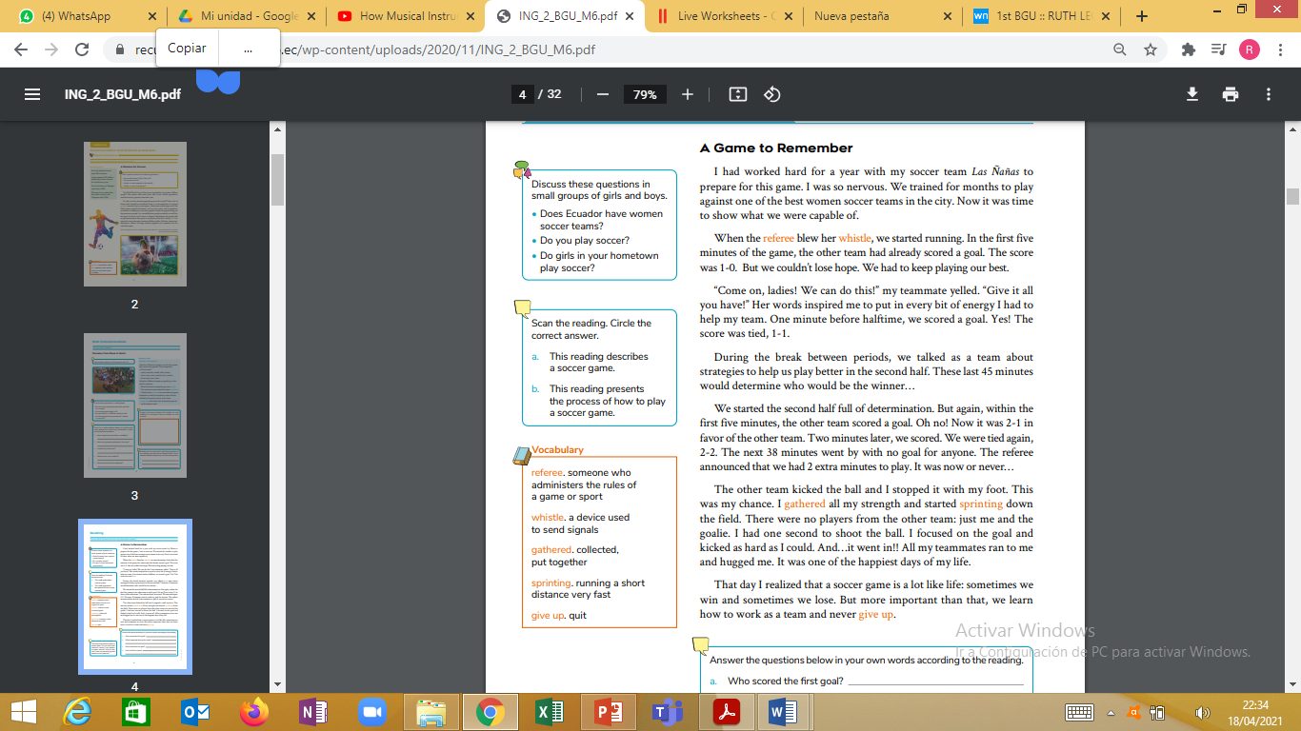
Link: https://drive.google.com/drive/folders/1Vh_SrYy2cxWsJEPXHcP5o-Mt4PkP9mqn?usp=sharing

Do you think women and men can play sports equally?
BEFORE READING
• Does Ecuador have women soccer teams?
• Do you play soccer?
• Do girls in your hometown play soccer?
DURING READING
Scan the reading. Circle the correct answer.
a. This reading describes a soccer game.
b. This reading presents the process of how to play a soccer game.
AFTER READING.
Answer the questions below in your own words according to the reading.
a. Who scored the first goal?
b. What happened during the break?
c. Who scored the last goal?
d. How is life like soccer?

