PROJECT 6 WEEK 1

8TH A: <https://drive.google.com/drive/folders/1H4kX3-SWMv4Kf7yyYTPGKZSH408RrtxL?usp=sharing>

8TH B: <https://drive.google.com/drive/folders/18VeOnLCgyj2T_xvFseOqIzBNFZmo_Obx?usp=sharing>

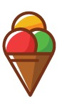

1.Classify.

**Sandwiches** **Fruit Salad Crisps Biscuits Water** **Cheese Fizzy drink Sausages Eggs Meat** **Fish Potatoes Beans Bananas Onions**

**Strawberrie Carrots Bread Rice Chocolate**

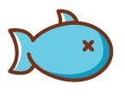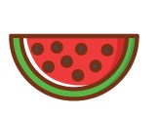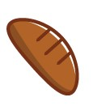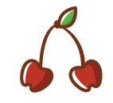

|  |  |  |  |
| --- | --- | --- | --- |
| Countables | | Uncountables | |
|  |  |  |  |
|  |  |  |  |
|  |  |  |  |
|  |  |  |  |
|  |  |  |  |
|  |  |  |  |