WEEK 5 PROYECTO 5

LINK PARA CARGAR EL DEBER

<https://drive.google.com/drive/folders/1VbNlk6zgWQTjx0BJx6w7q1m5SDMV736z?usp=sharing>

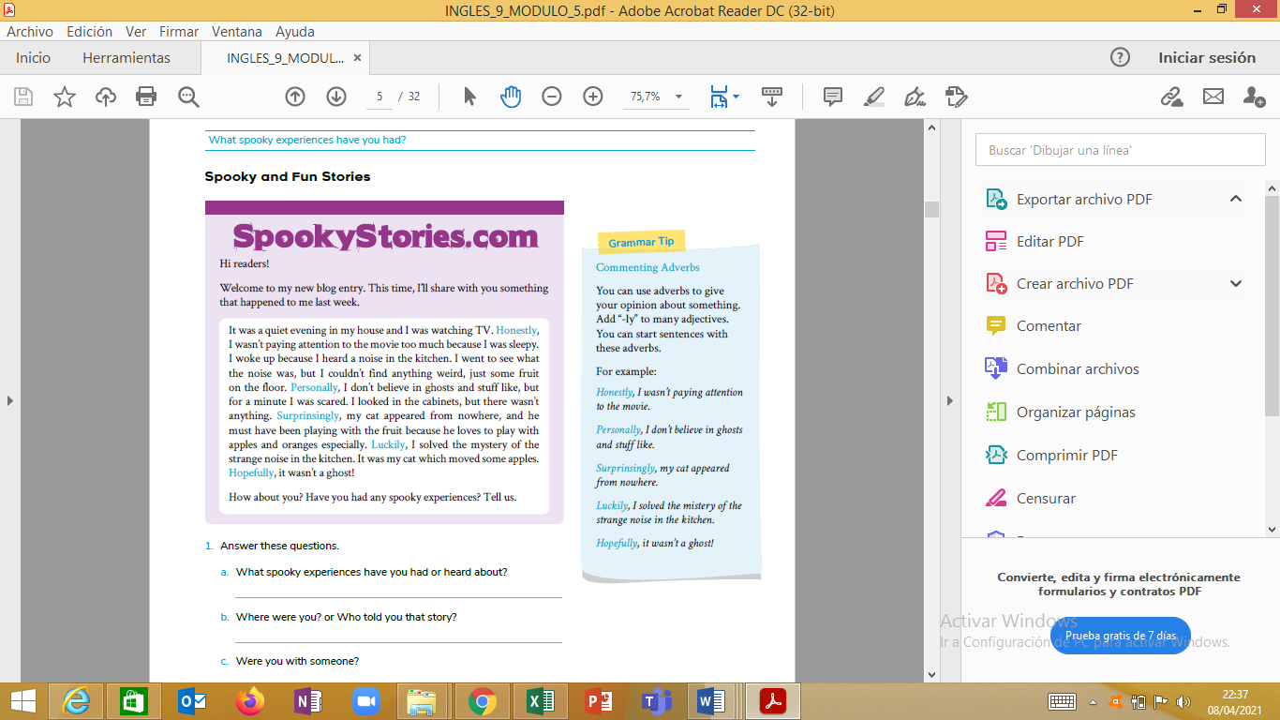

1. Answer these questions.

a. What spooky experiences have you had or heard about?

Honestly, I have heard about……………………………………..

b. Where were you? or Who told you that story?

I was ……………………………………………….

My_________ told me_____________

c. Were you with someone?

Luckily, I solved the mister because I was with my __________________

d. What happened at the end?

Hopefully, it was….

2. Use your answers from the previous activity and write your a paragraph

about a spooky event.

__________________________________________________________

_________________________________________________________

_________________________________________________________