PROYECTO 5 WEEK 2
MARCHS 19TH
LINK PARA SUBIR EL DEBER
https://drive.google.com/drive/folders/18bGOfTM46VbSAWXFXo18hN4YAdv1x5QD?usp=sharing
How stressful would it be to have a job as a 911 dispatcher?
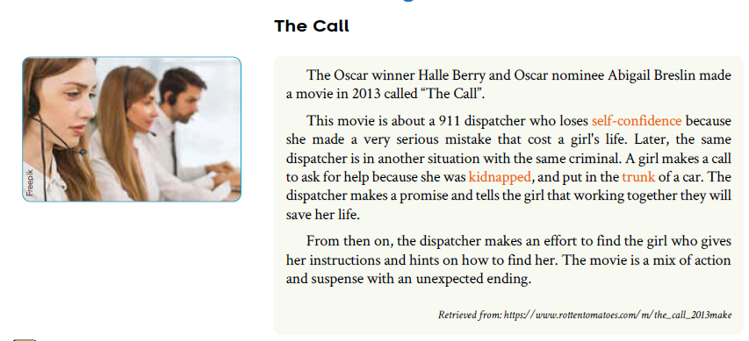
1. Circle the letter that is the main idea of the passage?
a. The girl was in the trunk of the car.
b. The movie is about a dispatcher tries to recover a girl who is kidnapped.
c. The dispatcher faced the same criminal who killed a girl before.

2. Write the letter of the expression next to the picture it describes.
a. Make a mistake
b. Make a call
c. Make a promise
d. Make an effort
e. Give instructions
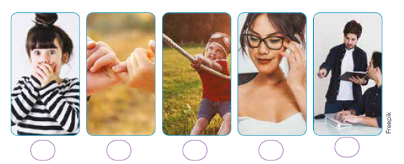
3. Complete the sentences by writing the correct expressions from exercise 2 in the blank spaces. Be careful to change he verb tense if needed and add words if necessary.

a. Oh no! I____________________ in a question of the test. I will lose a point.
b. Don’t fight. You are siblings. Let’s _________________________that you will respect each other.
c. I don’t know how to handle this machine. Can you to __________________________do it correctly?
d. A: I don’t understand it!
B: Come on, Anita. _______________________________ and you will understand it.
e. Excuse me, may I use your phone? I need to .______________________

