WEEK 2 PROYECT 5

Link: <https://drive.google.com/drive/folders/1eiimopJg9ydPRR-OkepkZokxBBDs-vVz?usp=sharing>

La Llorona

Read this interview. Two people are talking about a common myth known as,

“*La llorona*”.

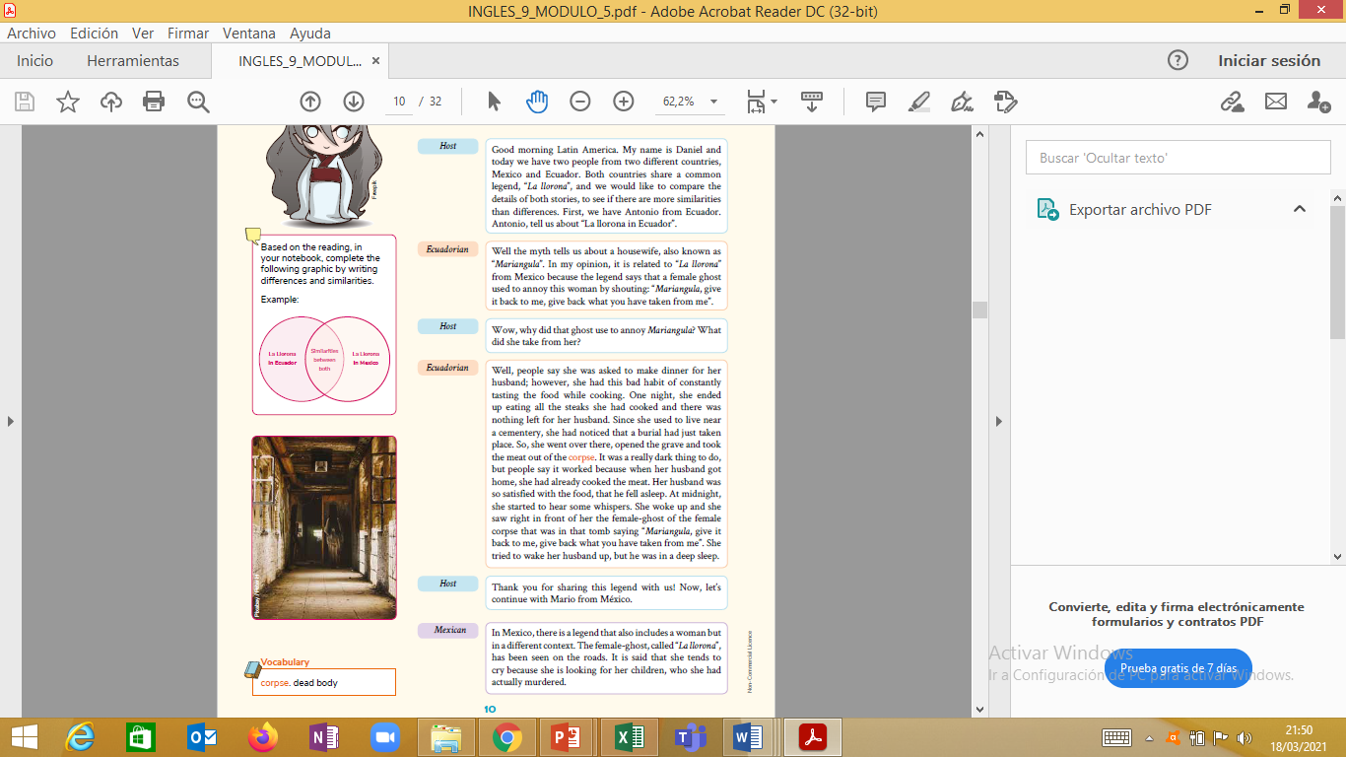

1. Answer the questions

a) Have you ever heard about “La Lorrona”

b) Have you ever heard about “ Maríangula”

c) Look for the meaning of unkown words.

c) Write a summary Mariangula.