Proyecto 5 semana 1

March 15th

<https://drive.google.com/drive/folders/1g22zMXGMJaNT0MH20mjIR33-M8BMbd3z?usp=sharing>

What happens in extreme weather conditions?

Balto, the Sled Dog Hero

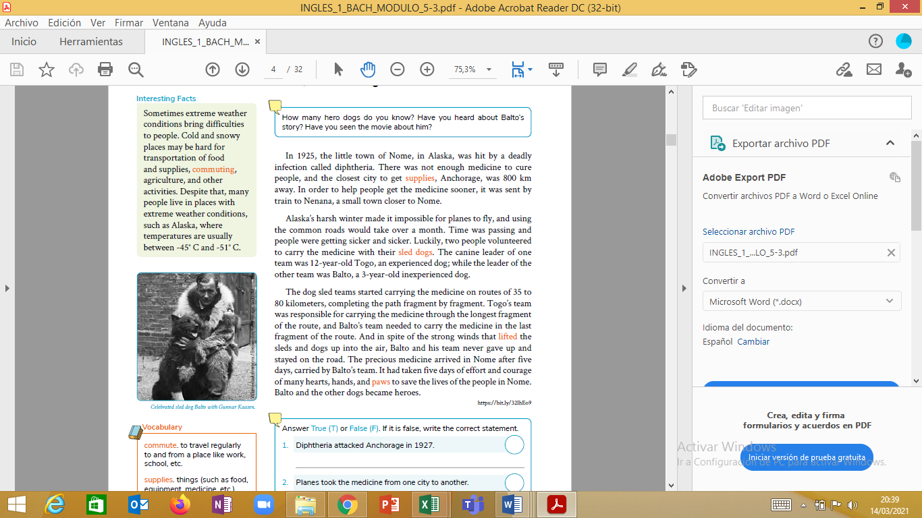

1. Answer True (T) or False (F). If it is false, write the correct statement.

1. Diphtheria attacked Anchorage in 1927. ------

2. Planes took the medicine from one city to another. -------

3. The medicine was transported only by Balto. -----------

4. The distance between Anchorage and Nome was 35 to 80 kms.----------

2)Look for the meaning of unknown words, at least 6 words.