PROYECTO 5 WEEK 1
MARCHS 12TH
LINK PARA SUBIR EL DEBER
https://drive.google.com/drive/folders/1XRcAFD2TsS0DBOsv3Mrm39-iM0TmbHxj?usp=sharing
a) Talk to your parents and answer these questions
1. What should you do when an emergency happens?
2. Have you ever called to 911? What happened?
3. Did you give the right information according to what we read? Explain.
4. What information did you give? Did your call help the situation? How?

b) Read the text:
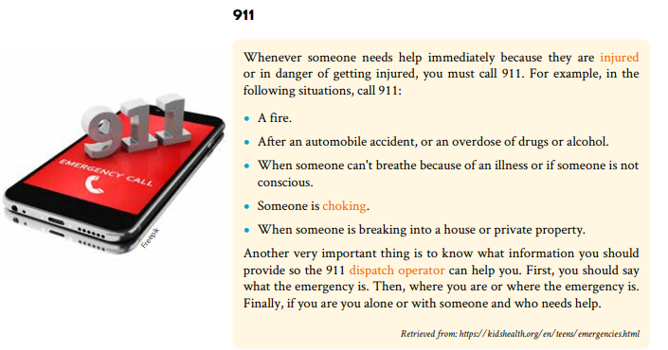
c) Discuss and answer the following questions.
a. What are some examples of serious emergencies?
-----------------------------------------------------------
-----------------------------------------------------------
----------------------------------------------------------
b. Why do you think it is important to call and give information before anything else?
---------------------------------------------------------------------------
c. Imagine an emergency happened right now where you are. What information would you give to the dispatcher? Write the information you have to give to the 911 dispatch operator. Check the text above for help.
A)____________________________
B)______________________________
C)________________________________
D)______________________________

