PROYECTO 5 WEEK 1

MARCHS 12TH

OCTAVO A: <https://drive.google.com/drive/folders/1ho75sEKsB-dDK17rrAbjM8nlLHwf5EYT?usp=sharing>

OCTAVO B: <https://drive.google.com/drive/folders/1ho75sEKsB-dDK17rrAbjM8nlLHwf5EYT?usp=sharing>

Activity 5: Free time activities

1. Look at the pictures and circle the free time activities you do

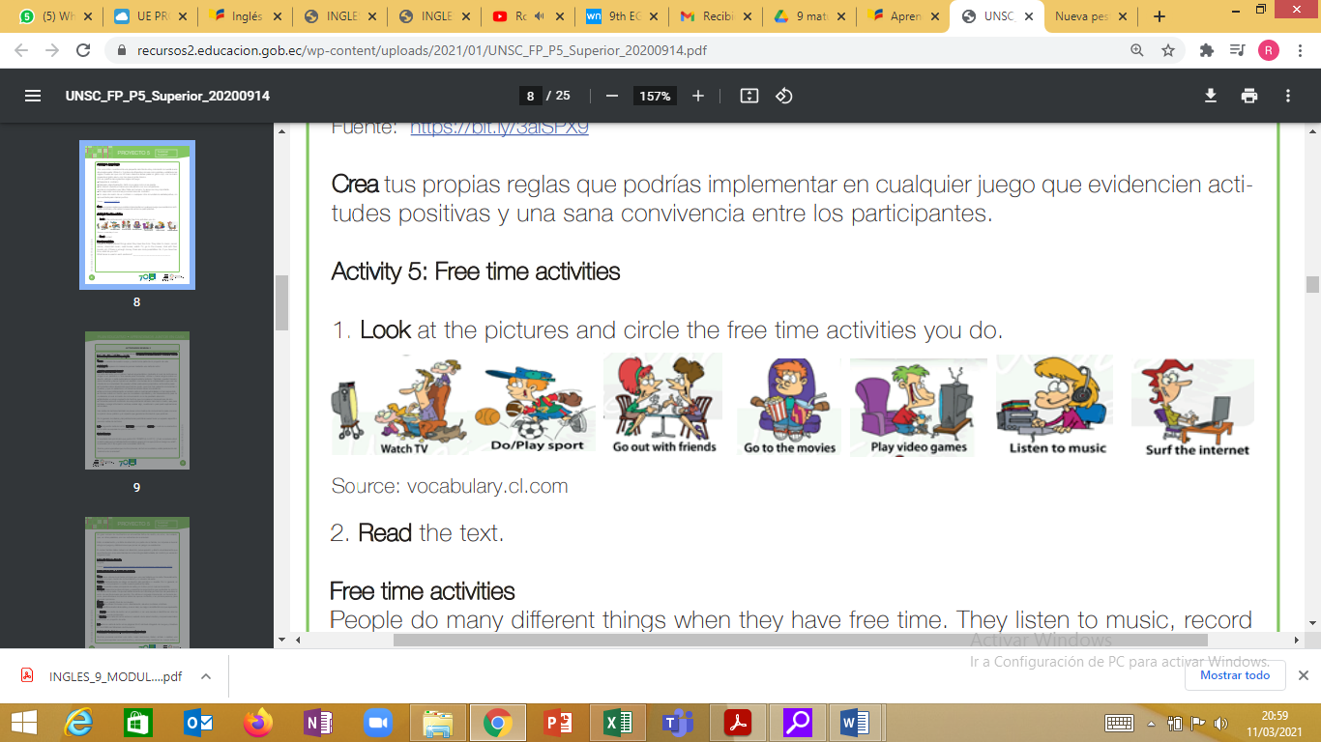

2. Read the text.

Free time activities

People do many different things when they have free time. They listen to music, record videos, download music, read books, watch TV, go to the movies, chat with their friends, etc. If there is enough money, there are more possibilities. So, if you have free time,

what do you do? WRITE 10 FREE TIME ACTIVITIES

1.

2.

3.

4.

5.

6.

7.

8.

9.

10.

What tense is used in each sentence? __________________________________