**PROYECTO 5 WEEK 1**

March 12th

<https://drive.google.com/drive/folders/14l_N9kLNB6VloGx9BiwLBJkx6YuDY-Cz?usp=sharing>

1. Is it possible that there are haunted castles in Europe?

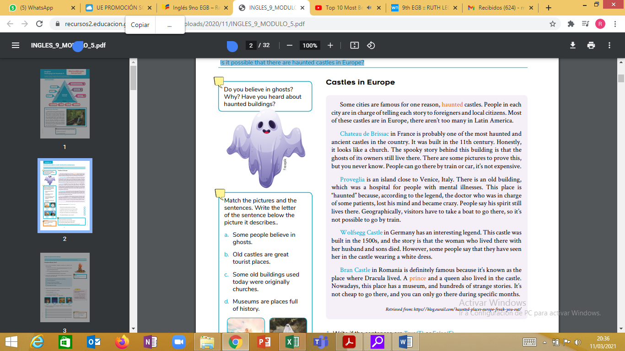

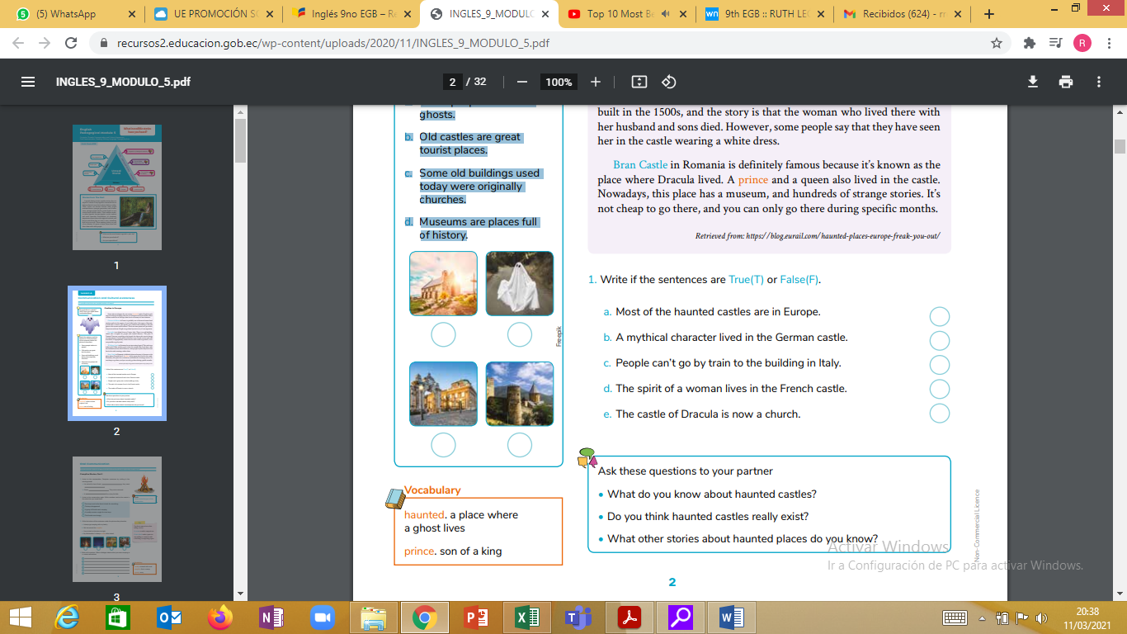2. Match the pictures and the sentences. Write the letter of the sentence below the picture it describes.

a. Some people believe in ghosts.

b. Old castles are great tourist places.

c. Some old buildings used today were originally churches.

d. Museums are places full of history.

**3. Write if the sentences are True(T) or False(F).**

a. Most of the haunted castles are in Europe. __________

b. A mythical character lived in the German castle._____ c. People can’t go by train to the building in Italy. ____

d. The spirit of a woman lives in the French castle. _____________

e. The castle of Dracula is now a church. ____________