**PROJECT 4 .**

[**https://drive.google.com/drive/folders/1ZUWAhoO-lwzbvY_Fd4xKq2j1C62A6wai?usp=sharing**](https://drive.google.com/drive/folders/1ZUWAhoO-lwzbvY_Fd4xKq2j1C62A6wai?usp=sharing)

How can we represent native animals through art?

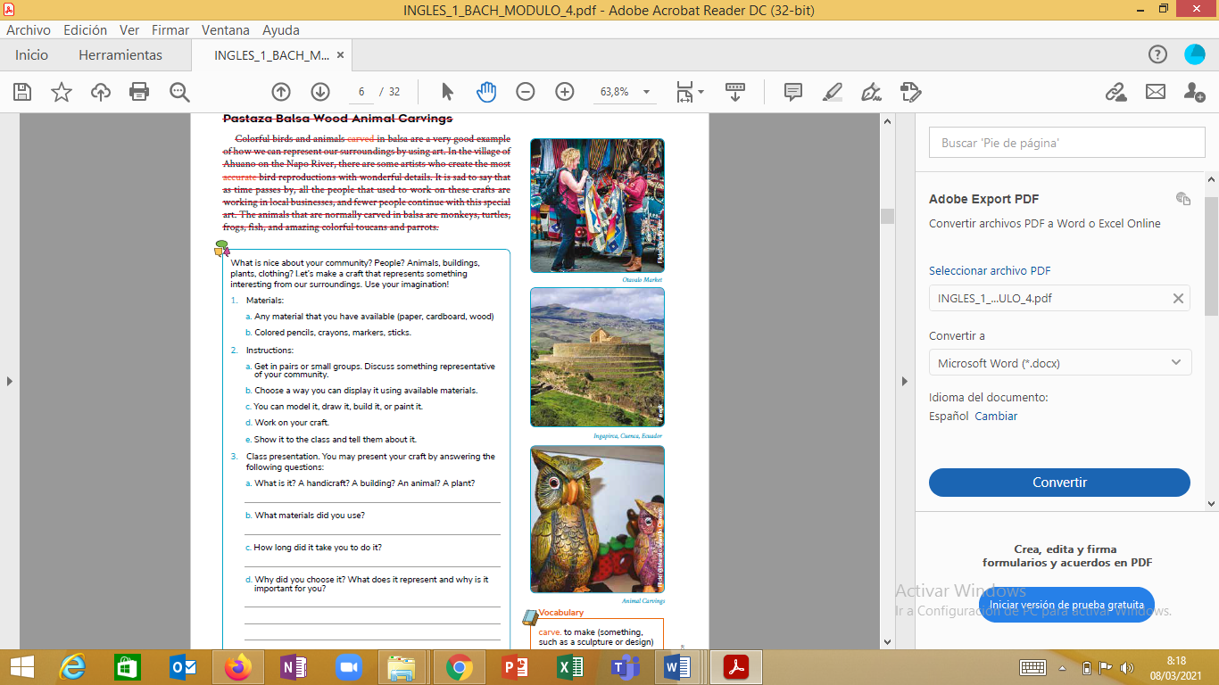Pastaza Balsa Wood Animal Carvings Colorful birds and animals carved in balsa are a very good example of how we can represent our surroundings by using art. In the village of Ahuano on the Napo River, there are some artists who create the most accurate bird reproductions with wonderful details. It is sad to say that as time passes by, all the people that used to work on these crafts are working in local businesses, and fewer people continue with this special art. The animals that are normally carved in balsa are monkeys, turtles, frogs, fish, and amazing colorful toucans and parrots.

Activities

What is nice about your community? People? Animals, buildings, plants, clothing? Let’s make a craft that represents something interesting from our surroundings. Use your imagination!

1. Materials:

a. Any material that you have available (paper, cardboard, wood)

b. Colored pencils, crayons, markers, sticks.

2. Instructions:

a. Discuss something representative of your community.

b. Choose a way you can display it using available materials.

c. You can model it, draw it, build it, or paint it.

d. Work on your craft.

e. Show it to the class and tell them about it.

3. Class presentation. You may present your craft by answering the

following questions:

a. What is it? A handicraft? A building? An animal? A plant?

b. What materials did you use?

c. How long did it take you to do it?

d. Why did you choose it? What does it represent and why is it importantfor you?