PROJECT 4 WEEK 5
https://drive.google.com/drive/folders/1D0_wl6I51O_79yKl_7r6J000XlhFMquZ?usp=sharing

How can we use codes to communicate?
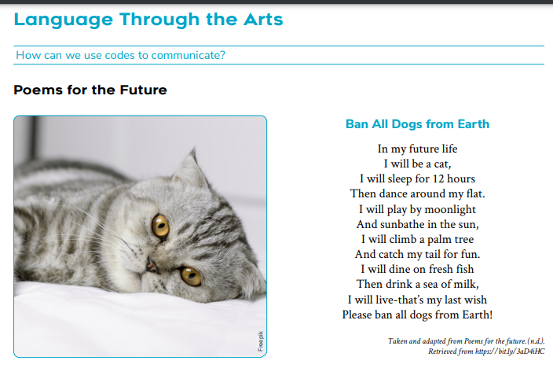

Represent this poem in a comic strip of 6 frames

