**PROJECT 4 WEEK 5.**

[**https://drive.google.com/drive/folders/1ZUWAhoO-lwzbvY_Fd4xKq2j1C62A6wai?usp=sharing**](https://drive.google.com/drive/folders/1ZUWAhoO-lwzbvY_Fd4xKq2j1C62A6wai?usp=sharing)

Why are Toquilla straw hats called “Panama hats”?

Have you ever heard about these kinds of hats? Does anyone in your family have one? Tell your classmates what you know about them.

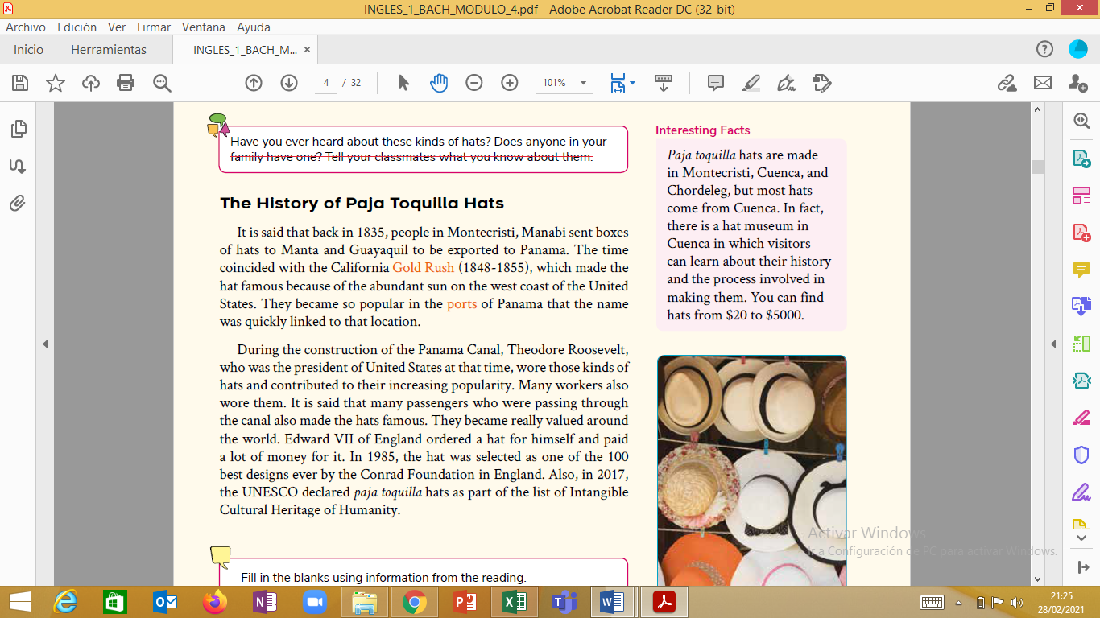 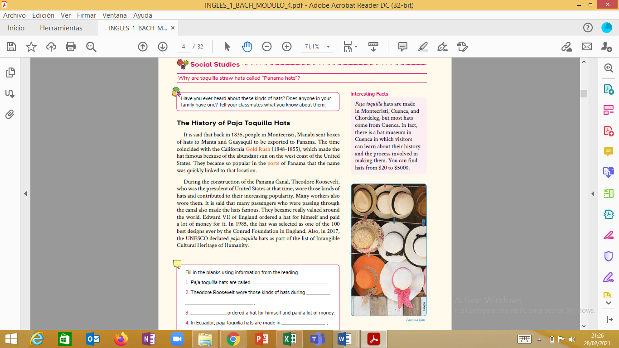

Fill in the blanks using information from the reading.

1. *Paja toquilla* hats are called________________________________

2. Theodore Roosevelt wore those kinds of hats during-------------------------------

______________________________________________________________

3. _____________________________________ordered a hat for himself and paid a lot of money.

4. In Ecuador, *paja toquilla* hats are made____________________________________ in and____________________________.

5. There is a museum about the history of hats in________________________________

6. Write 4 interesting facts about the history of *paja toquilla* hats.

________________________________________________________________________________________________________________________________________________________________________________________________________________________________________________________________________________________________________________