HOMEWORK WEEK 4

<https://drive.google.com/drive/folders/1VUmUnW43UAuAe9uVCgFUXaE99-B6wHIS?usp=sharing>

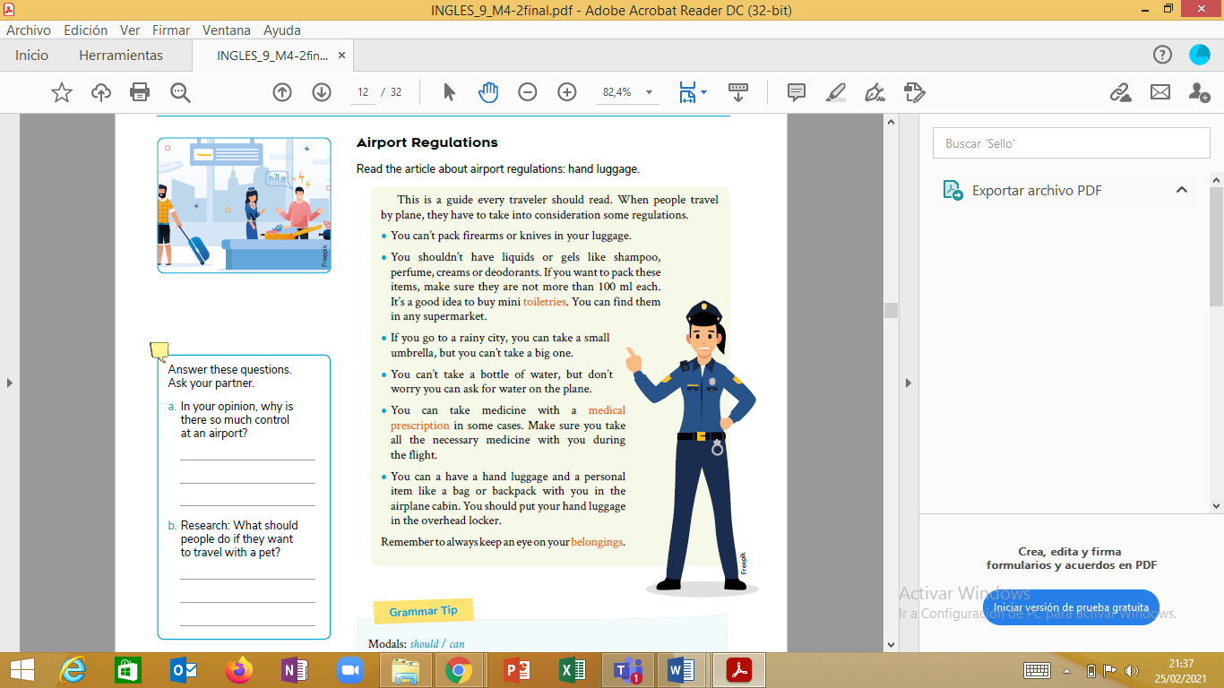 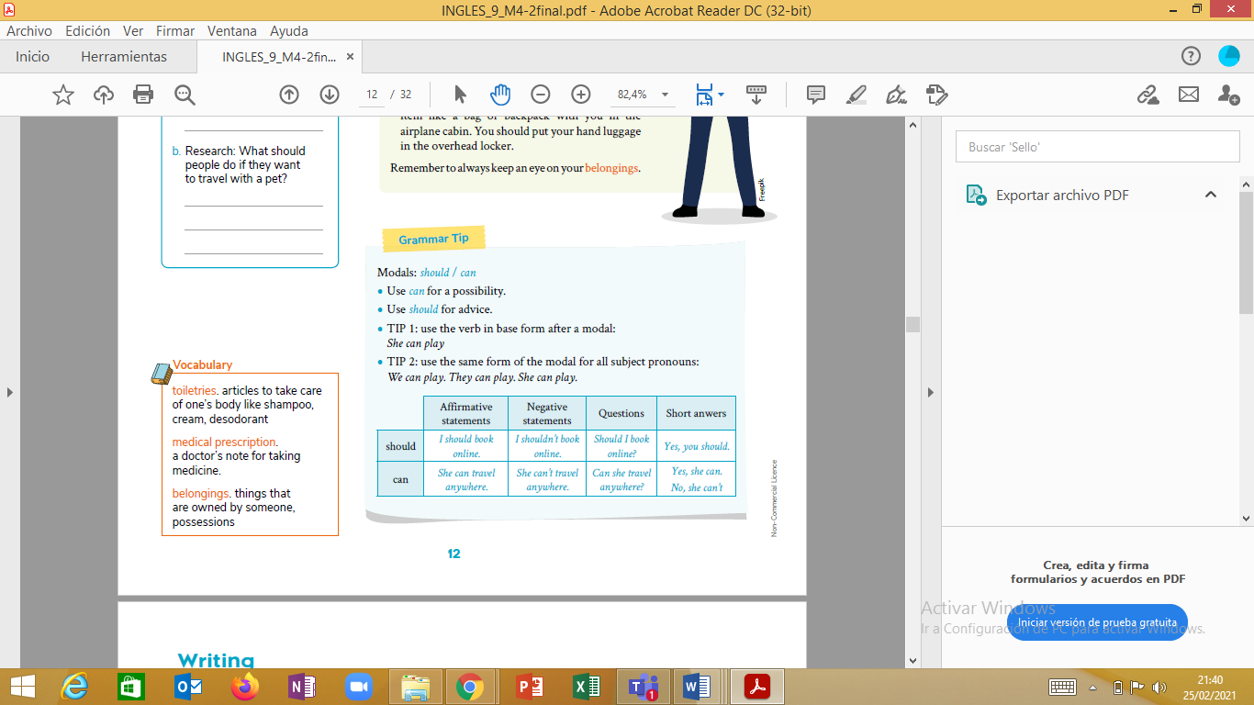

BASED ON THE READING DO THE ACTIVITIES

**1) Look for the meaning of the followings words**

1. toiletries__________________

2. medical prescription_____________

3. belongings______________________

4) hand luggage________________

**2) write true or false according to the reading**

a) You can pack firearms or knives in your luggage______

b) You should have liquids

c) You can´t have a hand luggage

**3) answer the questions**

1) How many ml should have liquids to pack?

2) When you can find mini toiletries?

3) Where you should put your hand luggage?