PROYECTO 4
WEEK 4 FEBRUARY 22TH
Link para cargar el deber
https://drive.google.com/drive/folders/1BAwI26hS_J8PBbtF8qypO9DCr3Cp4pNf?usp=sharing

VOCABULARY PERSONALITY TRAITS pag.2
In your notebook write the meaning of each word in blue color, then study for the next class.
Positive Negative
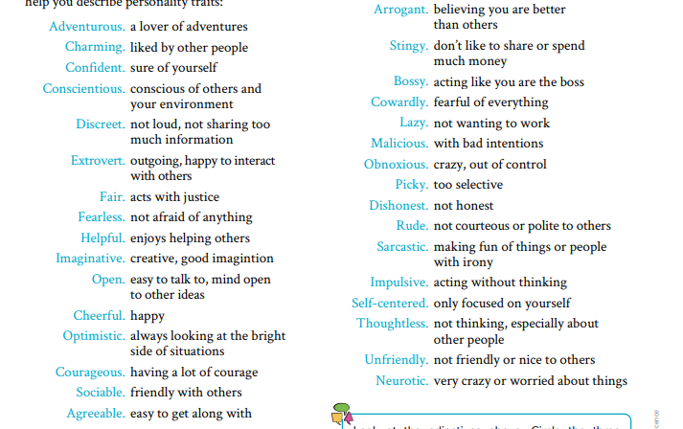

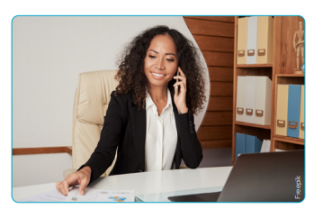
The Person Who Has Made a Difference in My Life
When I think about the person who has made a difference in my life, the first person that comes to mind is my mother. She taught me a lot of things, and the most important thing is she made me want to become a successful businesswoman.
When I was young, my mother told me about life, the best way to live, and how to be a good person. She is really the most influential person in my life. Growing up and seeing my mother owning and running a prosperous store helped give direction to my life. She was the one who taught me how to run a productive business and taught me several key points to having a business. One of her tips to having a wealthy business was to always provide excellent customer service and to satisfy every customer.
Seeing my mother as an efficient business person has made me aspire to have my own business one day. Although she is a busy manager in her company and her own business, my mother still has time to take care of our family.
My mother is my idol. As I look back at the things I have done in life, it would not have been possible without having someone special like my mother in my life. She has given me endless support and love. I am very thankful and blessed to have her.
Martina
Answer the questions
1)After reading about the person who has made a difference in Martina´s life, deduce meaning from context. Write a short definition or a synonym for these words:
Business: _____________
Business person: Productive:______________
Idol: __________________
2) Using vocabulary from page 2, write and explain 5 traits that describe Martina´s mother’s personality:
1.
2.
3.
4.
5.
3) Mention two reasons why Martina´s mother’s business is so successful.
1.
2.
4) Summarize the paragraph in 3 lines

