PROYECTO 4 SEMANA 2 11 DE FEBRERO
Link para cargar los deberes
DECIMO A: https://drive.google.com/drive/folders/1vrNMYy18wCyOYjMgM_BQFs3CMNV1wktr?usp=sharing

ACTIVITY: TRABAJAR EN LA WORSHEET QUE ESTÁ A CONTINUACIÓN
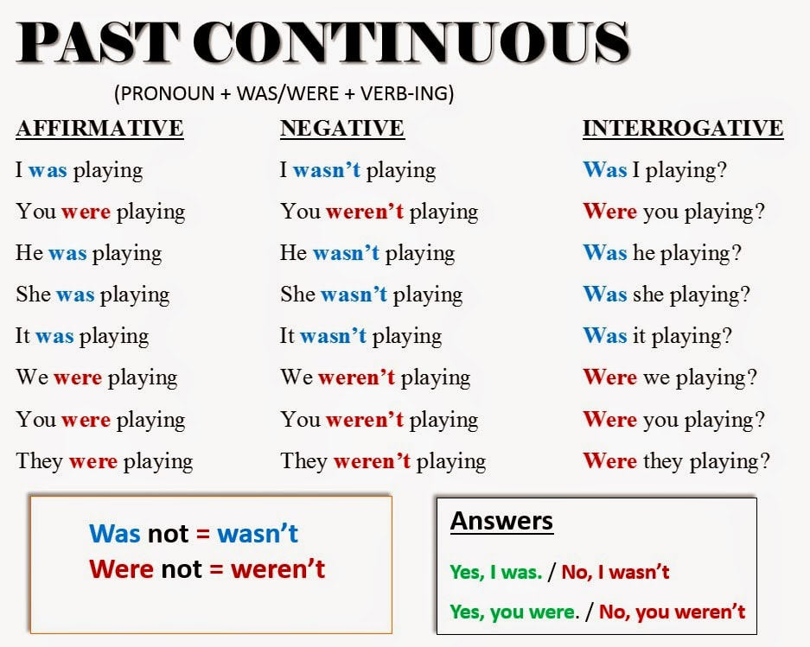

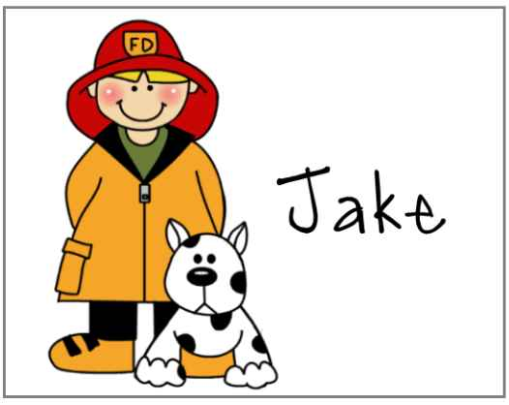
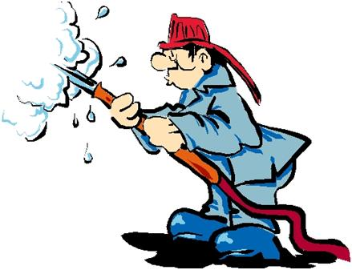
Aren't firefighters cool?
Yesterday I was playing videogames in my room when I heard people screaming. I went out and saw: my neighbors’ house was on fire!
In less than 10 minutes the firemen arrived and fought against the fire for one hour until they made it. Wow! They are really brave! One of them entered the house and saved the Johnson’s dog that was trapped in the fire.
I made a decision: I want to be a fireman when I grow up. I’ll be strong and brave enough to fight against the fire, to save people’s lives and property. I can’t wait! I can already see it in the newspaper: “Brave fireman rescues a family of four”, Mom will be really proud.

Mark true (T) or false (F). When it’s false, you’ll have to justify your answer orally:
The boy’s house was on fire. ( )
The boy thinks the firemen are brave. ( )
He admires the firefighters. ( )
It took long the firemen to arrive. ( )
It took one hour to extinguish the fire. ( )
The boy’s neighbors have a pet. ( )
A fireman saved the dog’s life. ( )
The boy wants to be a firefighter when he grows up. ( )
He wants to be as strong and brave as the firefighters. ( )
Answer the questions:
What was the boy doing when the neighbors’ house caught fire?
______________________________________________________________
Did he want to be a fireman before that day?
______________________________________________________________
Why did he decide to be a fireman in the future?
_______________________________________________________________
What qualities does he think are essential for being a fireman?
_______________________________________________________________
What can he already see in the newspaper?
________________________________________________________________
Who do you think the newspaper is referring to?
______________________________________________________________
How does the boy think his mother will feel? Do you agree with him?
______________________________________________________________
__________________________________________________________________

