PROYECTO 4 SEMANA 2 11 DE FEBRERO

Link para cargar los deberes

NOVENO A: <https://drive.google.com/drive/folders/1OVrR2VDaDMvp6xFiPDvMlRzBuNlDlFDa?usp=sharing>

ACTIVITY: Answer these questions

Have you ever traveled abroad?

Have you ever been to an airport?

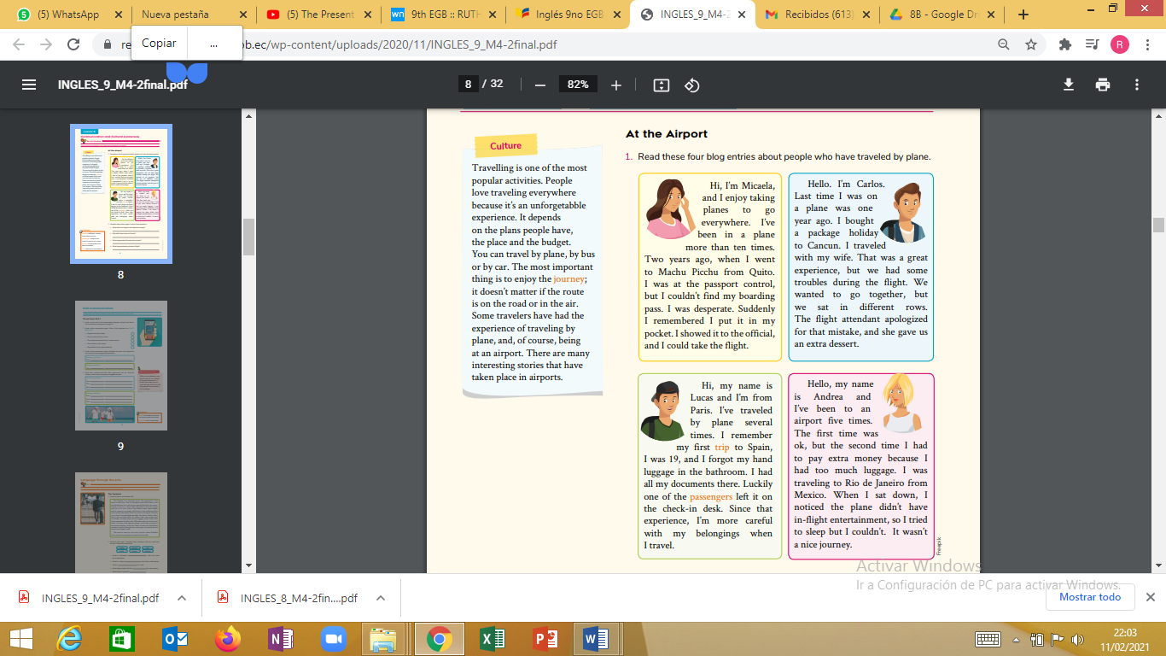

2. Read the blog entries again.

Answer these questions.

a. What did Lucas forget in the departure lounge?

b. Why did Carlos travel to Cancun?

c. What happened to Micaela at the airport?

d. What happened during Andrea’s flight?