PROYECTO 4 SEMANA 2 11 DE FEBRERO

Link para cargar los deberes

Octavo A: <https://drive.google.com/drive/folders/1lb1mTnzTbTBwWHDZtSe2rfDQnT4IHCju?usp=sharing>

OCTAVO B: <https://drive.google.com/drive/folders/1rEorwGISmetaBTfW9f-qLoDd-nDsRjLw?usp=sharing>

Have you ever been to the movies? What type of movies do you like to watch?

1. Homework

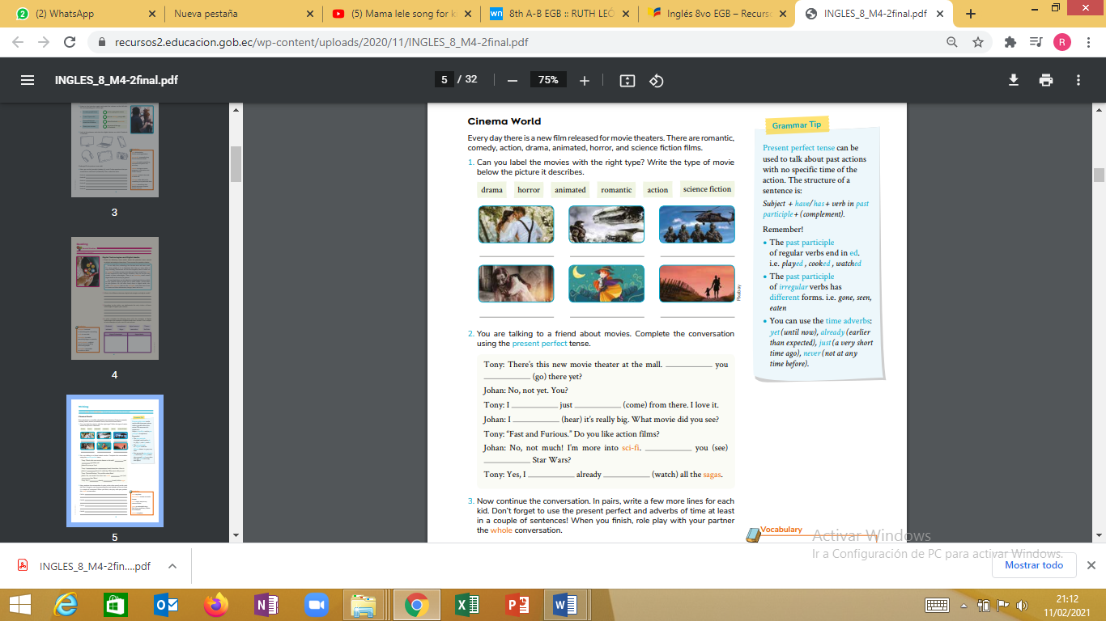 

action

romantic

Science fiction

animated

horror

drama

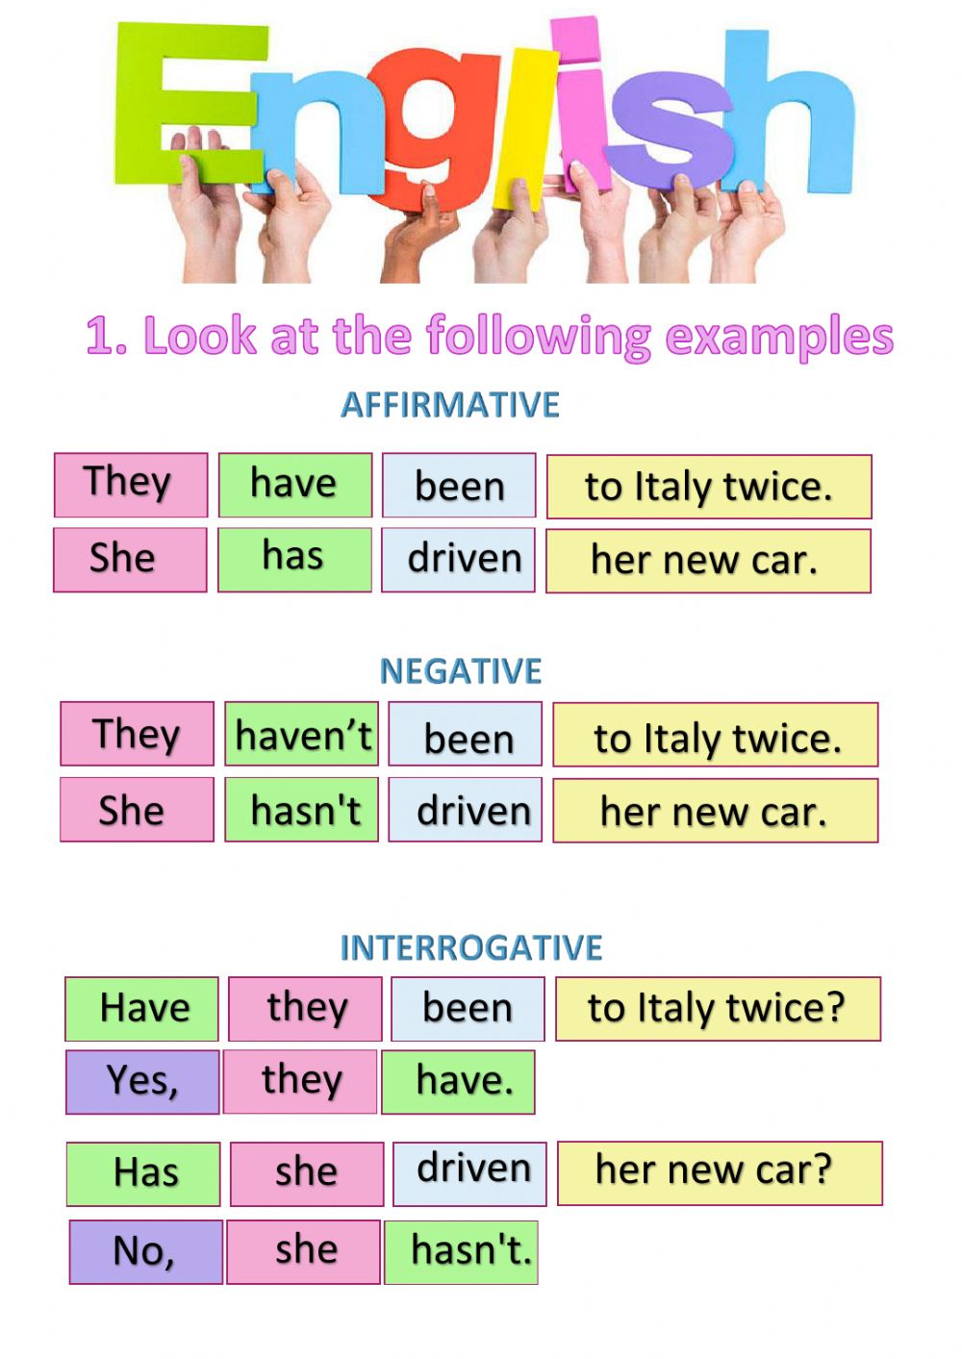

**2. You are talking to a friend about movies. Complete the conversation using the present perfect tense.**

Tony: There’s this new movie theater at the mall. __________you (go) ________________there yet?

Johan: No, not yet. You?

Tony: I ____________just __________(come) from there. I love it. Johan: I____________ (hear) it’s really big. What movie did you see? Tony: “Fast and Furious.” Do you like action films?

Johan: No, not much! I’m more into sci-fi. _____________you (see) _______________Star Wars?

Tony: Yes, I___________ already__________ (watch) all the sagas.