Proyecto 4

Week 2 February 8th

Link para cargar la tarea

<https://drive.google.com/drive/folders/12kD1rf6bgeGDMH7PjbyGzjDQZxdMJvHQ?usp=sharing>

**Wonderful Ecuador**

1. read the following paragraph and answer the questions:

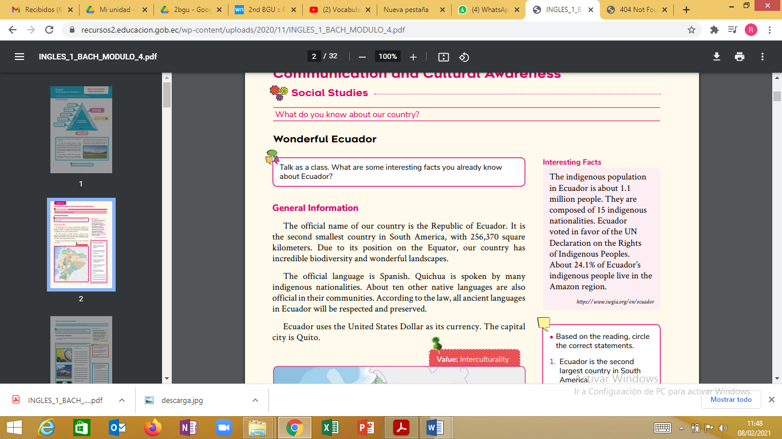

**2. Based on the reading, circle the correct statements.**

1. Ecuador is the second largest country in South America.

2. We have great biodiversity because we are far from the Equator.

3. About 12 languages are spoken in our country.

4. Approximately 24.1% of indigenous people live in the Amazonia.

5. All ancient languages in Ecuador won’t be respected and preserved.

**3. answer the questions**

a. What is the Ecuador´s currency?

b. How many indigenous people are there in Ecuador?

c. How many indigenous nationalities are there in Ecuador?