PROYECTO 4
FEBRERO 5 INVENTIONS
LINK PARA CARGAR EL DEBER
https://drive.google.com/drive/folders/1ny29viBwoCa6vUwP5XMdm6x-kP_8ej6H?usp=sharing
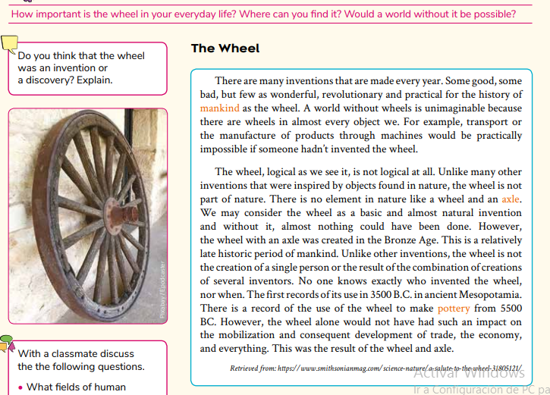

Select the correct option.
1. If nobody had invented the wheel, we wouldn’t...
- have learned to communicate
- have invented machines
- had crops
2. Trade and mobilization would have been almost impossible if the people in Mesopotamia...
- hadn’t invented the wheel amazing
- had discovered pottery
- hadn’t found bronze impossible
3. If the wheel and axle had existed in nature, it would have been _______ to come up with the idea of wheel and axle.
- amazing
- natural
- impossible
4. Why do you think the wheel was invented so late in history?
--------------------------------------------------------------------------------------------------------
5. How do you imagine life before the wheel?
--------------------------------------------------------------------------------------------------------------

