PROYECTO 4

FEBRERO 5 INVENTIONS

LINK PARA CARGAR EL DEBER

<https://drive.google.com/drive/folders/1_yPoAvDE_7Ege9TJK5DtnKg1ya-M11kW?usp=sharing>

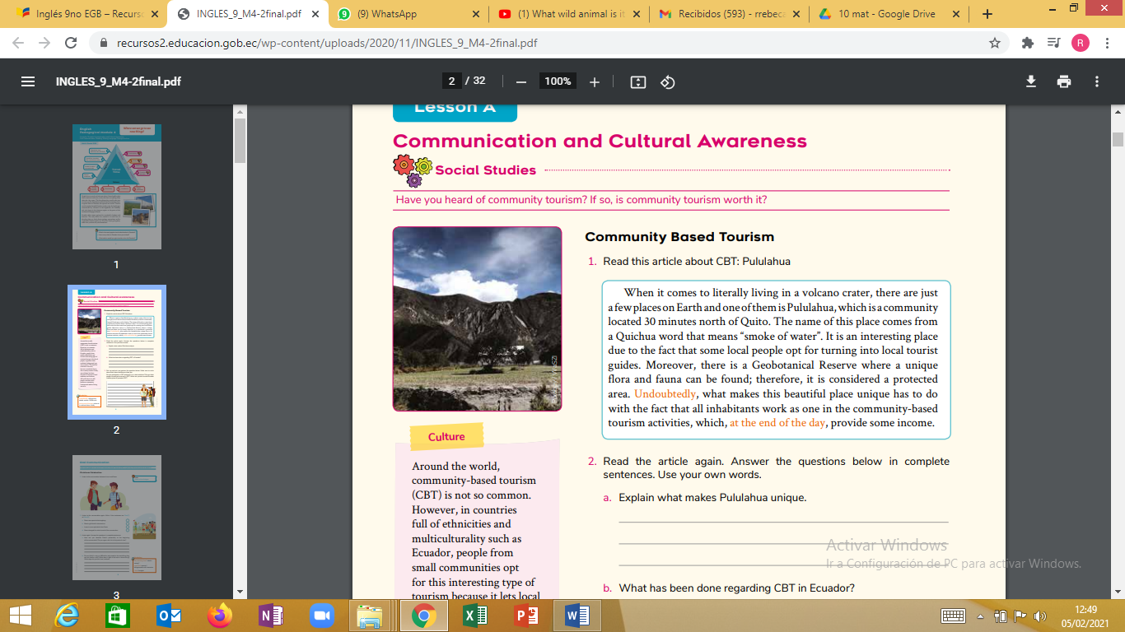

Read the article again.

Answer the questions below in complete sentences. Use your own words

a. Explain What makes Pululahua unique.

b. Where Pululahua is located?

c. What does Pululahua word means?

e. What advice would you give tourists who visit Ecuador?

f. What’s the most popular tourist destination in Ecuador?

g. How many cities in Ecuador have you visited?