Activity
Proyect 3
Week 5
1. Anwers the followin questions.
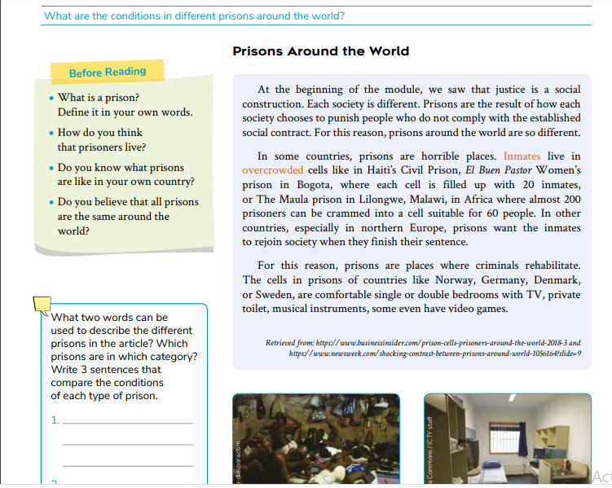
1. According to the text how are prisons around the world different?
2. What does the “social contract” have to do with the amount of people in a cell?
3. In which of the two categories of the text are prisons in your country?

