**HOMEWORK**

**COMPLETE THE FOLLOWING SENTENCES**

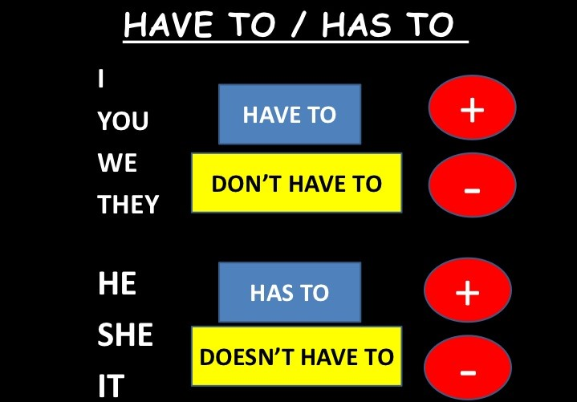 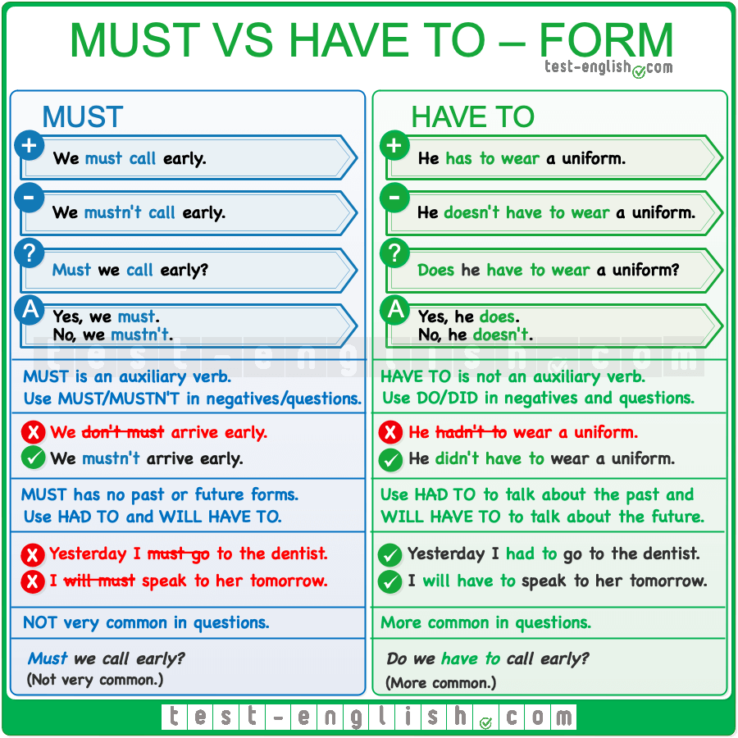

|  |  |
| --- | --- |
| AFFIRMATIVE | NEGATIVE |
| 1. they ________write a test.  2. She------------clean her desk.  3. Ken and Liz_______ learn English.  4. Andy __________ help his brother.  5. we ____________do our homework.  6. He_____________ write with a pencil.  7. I _________________ feed the hamster.  8. You _____________take photos.  9. Victoria ___________________-read the newspaper.  10. The teacher_________________ send a text message. | 1. they ________write a test.  2. She------------clean her desk.  3. Ken and Liz_______ learn English.  4. Andy __________ help his brother.  5. we ____________do our homework.  6. He_____________ write with a pencil.  7. I _________________ feed the hamster.  8. You _____________take photos.  9. Victoria ___________________-read the newspaper.  10. The teacher_________________ send a text message. |