**CLASSWORK**

**PROYECT 3**

**WEEK 5**

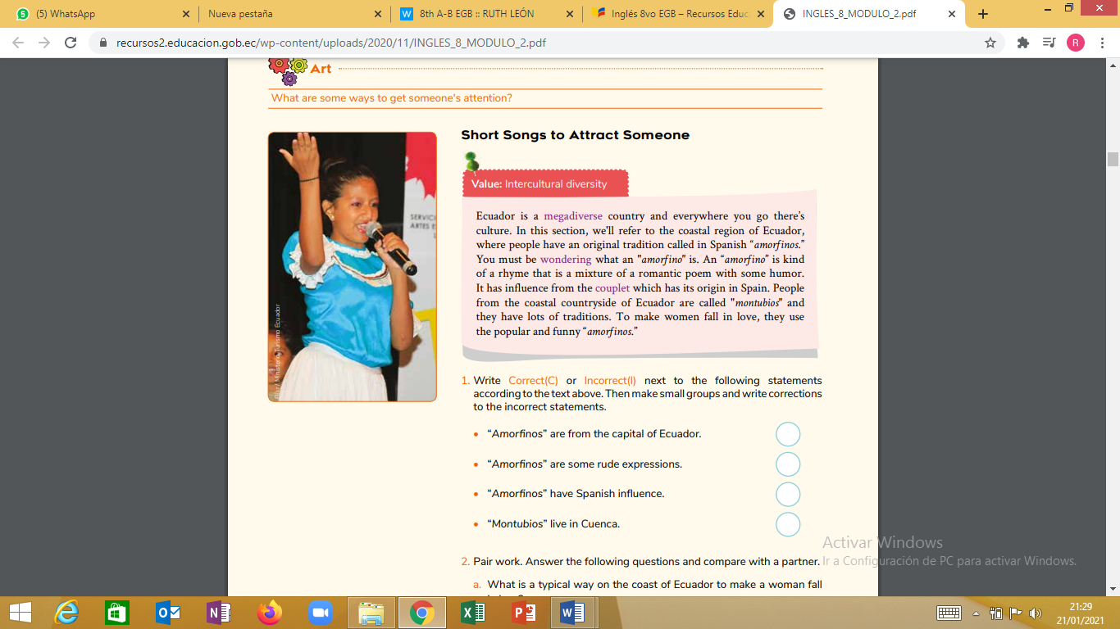

**1. Write Correct(C) or Incorrect(I) next to the following statements according to the text above. Then make small groups and write corrections to the incorrect statements.**

• “Amorfinos” are from the capital of Ecuador.

• “Amorfinos” are some rude expressions.

• “Amorfinos” have Spanish influence.

• “Montubios” live in Cuenca.

**2. Answer the following questions and compare with a partner.**

a. What is a typical way on the coast of Ecuador to make a woman fall in love?

b. Describe with your own words what "amorfinos" are.

c. In your city or town, what does a boy do to get a girl’s attention?

d. Challenge! In your notebook, write an "amorfino" in your own language. Share it with your partner and ask him/her if he/she likes it.