|  |  |  |
| --- | --- | --- |
|  | **UNIDAD EDUCATIVA “LUIS ROBERTO BRAVO”**  **CIUDADELA CATÓLICA. BARRIAL BLANCO Y ORDOÑEZ CRESPO.**  TELÉFONO 2341209  CUENCA-ECUADOR  Email: [lrbravo@hotmail.com](mailto:lrbravo@hotmail.com) | **School Year**  **2020 - 2021** |

|  |  |  |  |  |  |
| --- | --- | --- | --- | --- | --- |
| **Teacher:** | Lic. Ruth León | | | **Date:** | November |
| **Area** | Foreign Language | **Class** | **1st BGU morning** | **School Year** | 2020 - 2021 |
| **Subject.** | English | | | **Time** | week 1 |
| **Skills and performance criteria**  **Activities** | | | | | |
| **TOPIC.**  **Indicaciones generales para la presentación de los deberes:**  **1. Número de proyecto (semana 1 proyecto 3)**  **2. Nombres completos del estudiante.**  **3. Curso**  **4. Fecha**  **5. La entrega del deber tiene que hacerlo mediante el link.**  **Recuerde todo lo solicitado anteriormente forma parte de su calificación no pierda puntos valiosos.**  [**https://drive.google.com/drive/folders/1MHTYetiOYYd3IxuV_2GCqD3R0snN5iY2?usp=sharing**](https://drive.google.com/drive/folders/1MHTYetiOYYd3IxuV_2GCqD3R0snN5iY2?usp=sharing)  **Fecha de recepción: Jueves 17 de diciembre del 2020.** | | | | | |

Investigate an invention and talk about it in the next class. Your grade will be according your presentation

5 points investigation and 5 points presentation.

You can choose any of these inventions and look for more information ( who invented; year, country, Evolution, advantages or disadvantages)

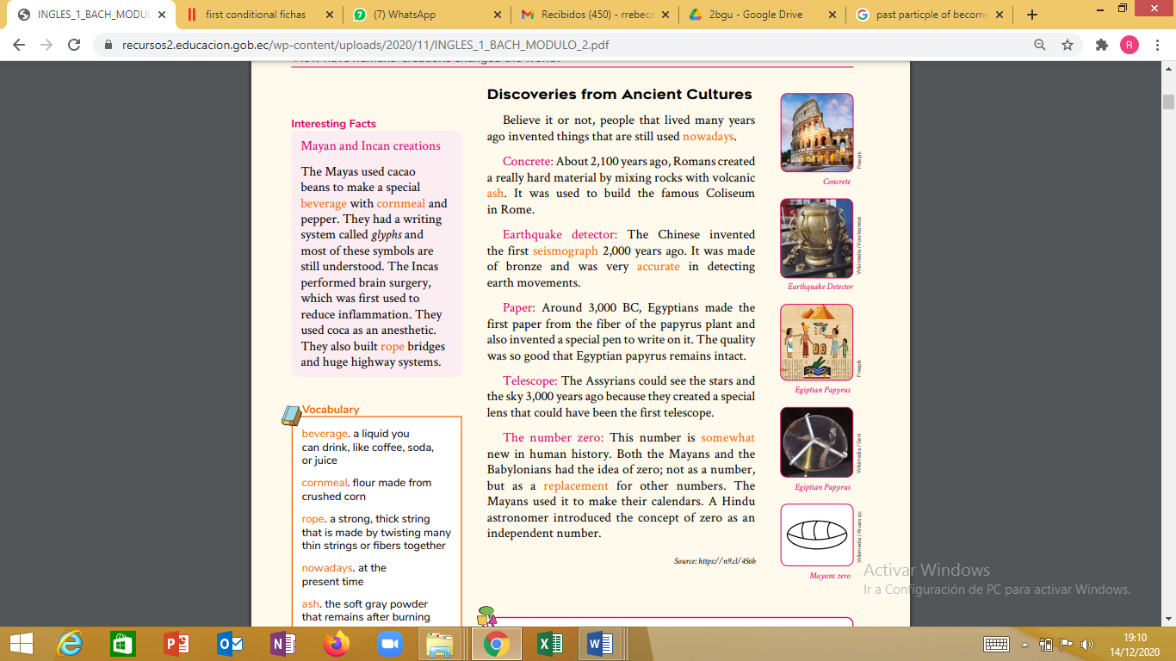

Invention

Inventors Picture