|  |  |  |
| --- | --- | --- |
|  | **UNIDAD EDUCATIVA “LUIS ROBERTO BRAVO”**  **CIUDADELA CATÓLICA. BARRIAL BLANCO Y ORDOÑEZ CRESPO.**  TELÉFONO 2341209  CUENCA-ECUADOR  Email: [lrbravo@hotmail.com](mailto:lrbravo@hotmail.com) | **School Year**  **2020 - 2021** |

|  |  |  |  |  |  |
| --- | --- | --- | --- | --- | --- |
| **Teacher:** | Lic. Ruth León | | | **Date:** |  |
| **Area** | Foreign Language | **Class** | **9th A morning** | **School Year** | 2020 - 2021 |
| **Subject.** | English | | | **Time** | week 13 |
|  | **Activities** | | | | |
| **1. Revisar la página** [**https://ruth-leon.webnode.es/english-8-a/**](https://ruth-leon.webnode.es/english-8-a/)  **Indicaciones generales para la presentación de los deberes:**  **1. Número de proyecto (semana ____ proyecto 2)**  **2. Nombres completo del estudiante**  **3. Curso**  **4. Fecha**  **5. La entrega del deber tiene que hacerlo mediante el link.**  **Recuerde todo lo solicitado anteriormente forma parte de su calificación no pierda puntos valiosos.**  [**https://drive.google.com/drive/folders/1IuSOkO7SQ8yX6dGaC6WvWaJy2qM948yC?usp=sharing**](https://drive.google.com/drive/folders/1IuSOkO7SQ8yX6dGaC6WvWaJy2qM948yC?usp=sharing)  **Link para subir la tarea**  **Fecha de entrega: viernes 27 de noviembre del 2020**  **Fecha de recepción: martes 1 de diciembre del 2020** | | | | | |

Places in the city

**Write sentences comparing the pictures. You can use the adjectives in the box.**

**Escriba oraciones comparativas con los adjetivos de la caja recuerde utilizar el adjetivo comparativo**

[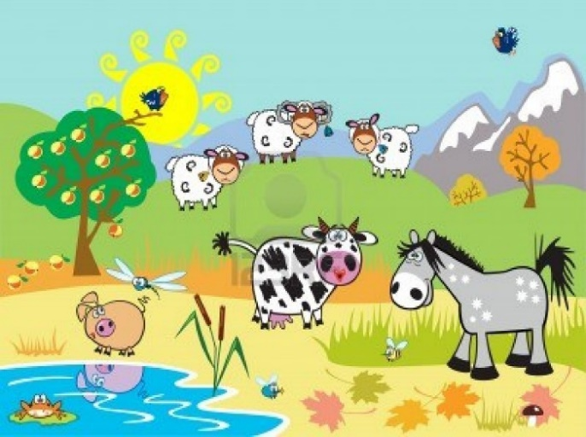](http://www.google.it/url?sa=i&rct=j&q=countryside+cartoon&source=images&cd=&cad=rja&docid=CUhWMs3WGqmJBM&tbnid=Ab4UT3pD9yeZlM:&ved=0CAUQjRw&url=/url?sa=i&rct=j&q=countryside+cartoon&source=images&cd=&cad=rja&docid=CUhWMs3WGqmJBM&tbnid=Ab4UT3pD9yeZlM:&ved=&url=http%3A%2F%2Fwww.123rf.com%2Fphoto_15503978_horizontal-landscape-with-childish-farm-animals-cartoon-images-children-illustration-for-little-kids.html&ei=9tJyUcqcJImm4gTMl4GwBw&bvm=bv.45512109,d.bGE&psig=AFQjCNHXeqVrFey7L-t-CovCUpwiof94Pw&ust=1366566006977913&ei=ltNyUfCOL4HoPIDsgIAE&bvm=bv.45512109,d.bGE&psig=AFQjCNHXeqVrFey7L-t-CovCUpwiof94Pw&ust=1366566006977913) [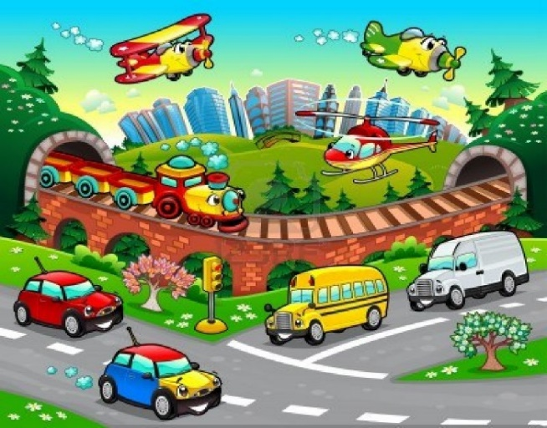](http://www.google.it/url?sa=i&rct=j&q=city+cartoon&source=images&cd=&cad=rja&docid=ybNzJrNa0zvb9M&tbnid=maHh0--YABeW_M:&ved=0CAUQjRw&url=http://www.123rf.com/photo_15216024_funny-vehicles-in-the-city-cartoon-and-vector-illustration.html&ei=7tNyUYzANMXPOaO9gdgJ&bvm=bv.45512109,d.Yms&psig=AFQjCNEMoJ7hoVusA9FydmyqtS26egggpw&ust=1366566037496432)

|  |
| --- |
| quiet – big – beautiful – bad - ~~clean~~ - noisy - healthy – good - interesting – pretty - loud |

**Example:** The country is cleaner than the city.

1. ________________________________________________________________
2. _______________________________________________________________
3. _______________________________________________________________
4. _______________________________________________________________
5. _______________________________________________________________
6. _______________________________________________________________
7. ________________________________________________________________
8. ________________________________________________________________
9. _______________________________________________________________
10. ________________________________________________________________