 | UNIDAD EDUCATIVA “LUIS ROBERTO BRAVO”  CIUDADELA CATÓLICA. BARRIAL BLANCO Y ORDOÑEZ CRESPO.  TELÉFONO 2341209  CUENCA-ECUADOR  Email: lrbravo@hotmail.com | School Year  2020 - 2021
Teacher: | Lic. Ruth León |  |  | Date: | NOVEMBER
Area | Foreign Language | Class | 2ND BGU MORNING | School Year | 2020 - 2021
Subject. | English |  |  | Time | week 12
 | Activities
Topic: Zero Conditionals
Indicaciones generales para la presentación de los deberes:
1. Número de proyecto ( semana 12 proyecto 2)
2. Nombres completos del estudiante.
3. Curso
4. Fecha
5. La entrega del deber tiene que hacerlo mediante el link.
Recuerde todo lo solicitado anteriormente forma parte de su calificación no pierda puntos valiosos.
https://drive.google.com/drive/folders/1cuvRaHme-C-h5zKeOUuDszlSXL-8YlpF?usp=sharing

Fecha de recepción: miércoles 18 de noviembre

Present Simple
Affirmative | Negativa | Interrogative
I think | I do not think | Do I think?
You think | You do not think | Do you think?
He thinks | He does not think | Does he think?
She thinks | She does not think | Does she think?
It thinks | It does not think | Does it think?
We think | We do not think. | Do we think?
They think | They do not think. | Do they think?

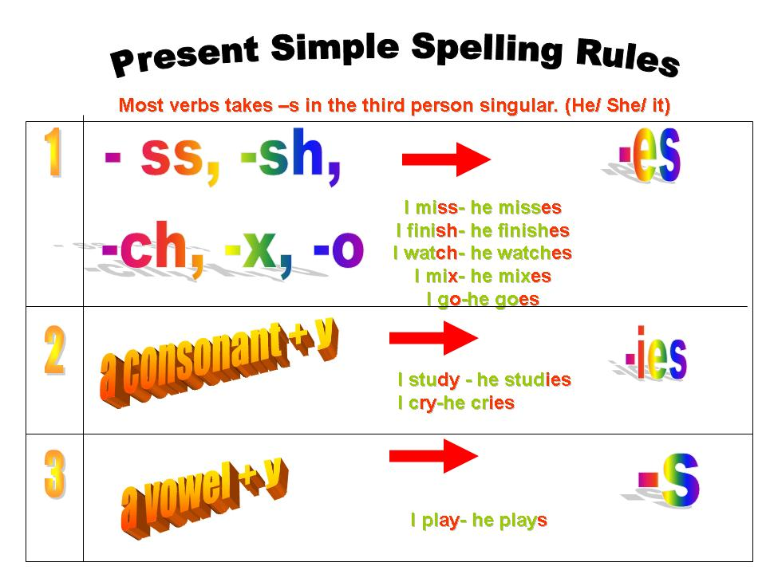

HOMEWORK

ZERO CONDITONAL
CONDITIONALS ABOUT FACTS
A. Choose the correct answers.


- You __________ the school rules if your phone rings during lessons.

  - break
  - will break
  - breaks

- If we put sugar in warm water, it _______________.
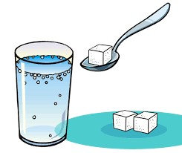
  - dissolves
  - dissolve
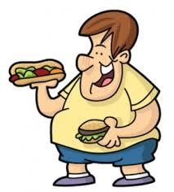
  - will dissolve

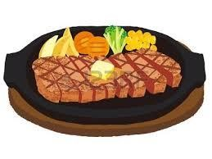
- We ____________ weight if we take in more calories than we need.

  - will gain
  - could gain
  - gain

- The steak ___________ if we overcook it.

  - burn
  - burns
  - will burn

- If we cut ourselves, we ___________________.
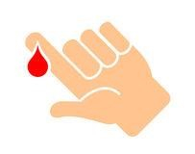
  - are bleeding
  - bleeds
  - bleed

- Match the correct answers.

1. If the iceberg melts, | ˙ | ˙ it finally stops.
2. If a glass falls onto the ground, | ˙ | ˙ the water level rises.
3. If a ball rolls along the ground, | ˙ | ˙ It breaks.

- Re-arrange the order of the words below to form conditional sentences.

1. / die. / If flowers / don’t get / they / any water, /
______________________________________________________________
2. / mix / you get / yellow and blue, / If you / green. /
________________________________________________

