|  |  |  |
| --- | --- | --- |
|  | **UNIDAD EDUCATIVA “LUIS ROBERTO BRAVO”**  **CIUDADELA CATÓLICA. BARRIAL BLANCO Y ORDOÑEZ CRESPO.**  TELÉFONO 2341209  CUENCA-ECUADOR  Email: [lrbravo@hotmail.com](mailto:lrbravo@hotmail.com) | **School Year**  **2020 - 2021** |

|  |  |  |  |  |  |
| --- | --- | --- | --- | --- | --- |
| **Teacher:** | Lic. Ruth León | | | **Date:** | November |
| **Area** | Foreign Language | **Class** | **1st BGU morning** | **School Year** | 2020 - 2021 |
| **Subject.** | English | | | **Time** | week 12 |
| **Skills and performance criteria**  **Activities** | | | | | |
| **TOPIC. Past continuous**  **Indicaciones generales para la presentación de los deberes:**  **1. Número de proyecto (semana 12 proyecto 2)**  **2. Nombres completos del estudiante.**  **3. Curso**  **4. Fecha**  **5. La entrega del deber tiene que hacerlo mediante el link.**  **Recuerde todo lo solicitado anteriormente forma parte de su calificación no pierda puntos valiosos.**  **Fecha de recepción: miércoles 19 de noviembre del 2020.**  <https://drive.google.com/drive/folders/1C_0URPmD0A9lq6quyKSVKxROy35j4e5V?usp=sharing> | | | | | |

Past continuous

Finish the activity 1 and 2 use was or were + ing form

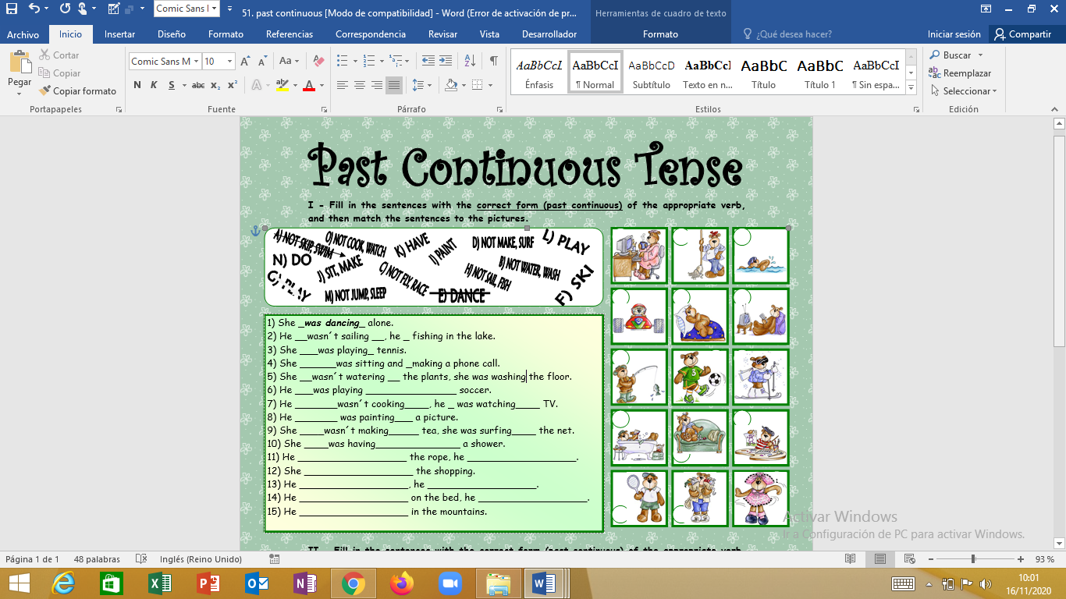

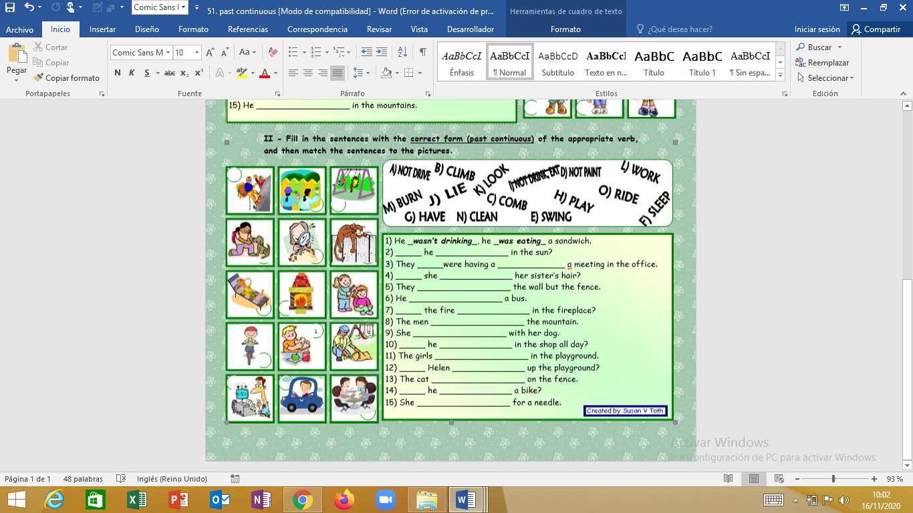

KEY

|  |  |  |  |
| --- | --- | --- | --- |
| I  1) She _***was dancing***_ alone. (E)  2) He wasn’t sailing, he was fishing by the lake. (H)  3) She was playing tennis. (L / G)  4) She was sitting and making a phone call. (J)  5) She wasn’t watering the plants, she was washing the floor. (B)  6) He was playing soccer. (G / L)  7) He wasn’t cooking, he was watching TV. (O)  8) He was painting a picture. (I)  9) She wasn’t making tea, she was surfing the net. (D)  10) She was having a shower. (K)  11) He wasn’t skipping the rope, he was swimming. (A)  12) She was doing the shopping. (N)  13) He wasn’t flying, he was racing. (C)  14) He wasn’t he jumping on the bed, he was sleeping. (M)  15) He was skiing in the mountains. (F) | 9 | 5 | 11 |
| 13 | 14 | 7 |
| 2 | 6 | 15 |
| 10 | 4 | 8 |
| 3 | 12 | 1 |
| II  1) He _***wasn’t drinking***_, he _***was eating***_ a sandwich. (I)  2) Was he lying in the sun? (J)  3) They were having a meeting in the office. (G)  4) Was she combing her sister’s hair? (C)  5) They weren’t painting the wall but the fence. (D)  6) He wasn’t driving a bus. (A)  7) Was the fire burning in the fireplace? (M)  8) The men were climbing the mountain. (B)  9) She was playing with her dog. (H)  10) Was he working in the shop all day? (L)  11) The girls were swinging in the playground. (E)  12) Was Helen cleaning up the playground? (N)  13) The cat was sleeping on the fence. (F)  14) Was he riding a bike? (O)  15) She was looking for a needle. (K) | 8 | 5 | 11 |
| 9 | 15 | 13 |
| 2 | 7 | 4 |
| 14 | 1 | 12 |
| 10 | 6 | 3 |

The background is from <http://www.cutecolors.com/>