|  |  |  |
| --- | --- | --- |
|  | **UNIDAD EDUCATIVA “LUIS ROBERTO BRAVO”**  **CIUDADELA CATÓLICA. BARRIAL BLANCO Y ORDOÑEZ CRESPO.**  TELÉFONO 2341209  CUENCA-ECUADOR  Email: [lrbravo@hotmail.com](mailto:lrbravo@hotmail.com) | **School Year**  **2020 - 2021** |

|  |  |  |  |  |  |
| --- | --- | --- | --- | --- | --- |
| **Teacher:** | Lic. Ruth León | | | **Date:** | November |
| **Area** | Foreign Language | **Class** | **1st BGU morning** | **School Year** | 2020 - 2021 |
| **Subject.** | English | | | **Time** | week |
| **Skills and performance criteria**  **Activities** | | | | | |
| **TOPIC. Past continuous**  [**https://www.youtube.com/watch?v=kHNwVK_IB-0**](https://www.youtube.com/watch?v=kHNwVK_IB-0)  Note: Realice las actividades solicitadas en lo que tenga a su disposición (cuaderno, hojas perforadas) subir al link que se adjunta a continuación; cada tarea debe tener: título, nombre del estudiante, curso, fecha y firma del representante. Presentar a tiempo sus actividades.  <https://drive.google.com/drive/folders/1SgbUSg6hTVXVOjOrM1SYpoGrO1Xd6-bY?usp=sharing>  **Fecha de recepción: miércoles 11 de noviembre del 2020.** | | | | | |

**PAST CONTINUOUS**

**The past continuous is used to express interrupted actions, specific time as an interruption and parallel actions**

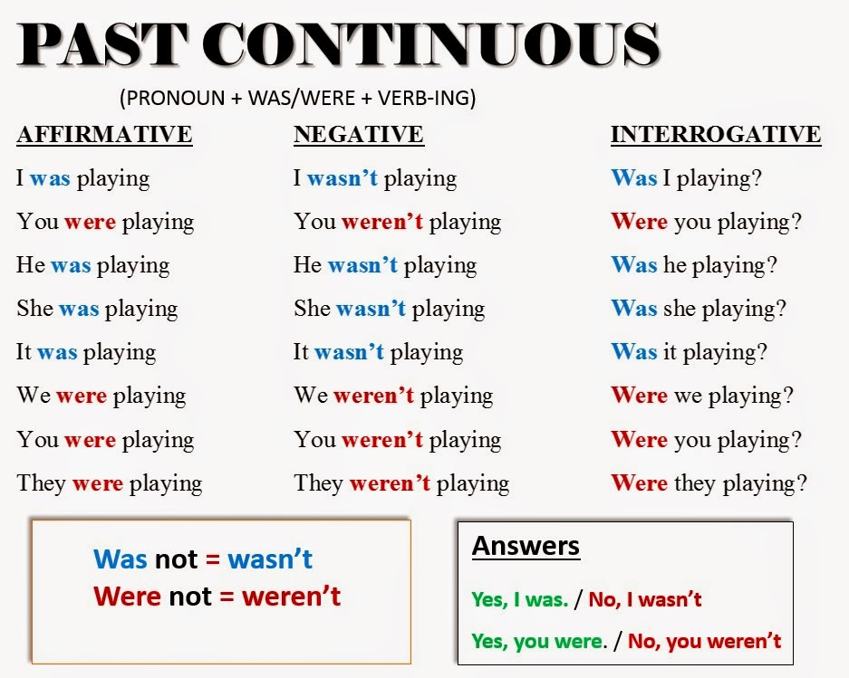

|  |  |  |  |
| --- | --- | --- | --- |
|  | AFFFIRMATIVE | NEGATIVE | INTERROGATIVE |
|  | I was studying (study) science for my test. | I was not /(wasn´t) studying science for my test. | Was I studying science for my test? Yes, I was / No, I wasn´t. |
| he____ (not do) his homework | He was doing his homework. | He was not/ (wasn´t) doing his homework. | was he doing his homework?. Yes, he was / No, he wasn´t |
| Jane, David and Polly_____ (watch) Tv when the light turned off. | Jane, David and Polly were watching (watch) Tv when the light turned off. | Jane, David and Polly weren´t watching (watch) Tv when the light turned off. | Jane, David and Polly weren´t watching (watch) Tv when the light turned off. |
| you____ ( play) rugby | You were playing rugby | you weren´t playing ruby | Were you playing rugby?  Yes, I was / No, I wasn´t |

