 | UNIDAD EDUCATIVA “LUIS ROBERTO BRAVO”  CIUDADELA CATÓLICA. BARRIAL BLANCO Y ORDOÑEZ CRESPO.  TELÉFONO 2341209  CUENCA-ECUADOR  Email: lrbravo@hotmail.com | School Year  2020 - 2021
Teacher: | Lic. Ruth León |  |  | Date: | OCTOBER
Area | Foreign Language | Class | 2ND BGU MORNING | School Year | 2020 - 2021
Subject. | English |  |  | Time | week
 | Activities
Topic: Zero Conditionals
video
https://www.youtube.com/watch?v=oBf1gXlrcqY

Note: Realizar las actividades solicitadas en lo que tenga a su disposición ( cuaderno, hojas perforadas) subir el deber al link que se encuentra a continuación.

https://drive.google.com/drive/folders/1FmEa9cGWE4uzgc5hUYNsz0T8MpbwdbFC?usp=sharing
Fecha de recepción: miércoles 13 de noviembre

ZERO CONDITIONAL
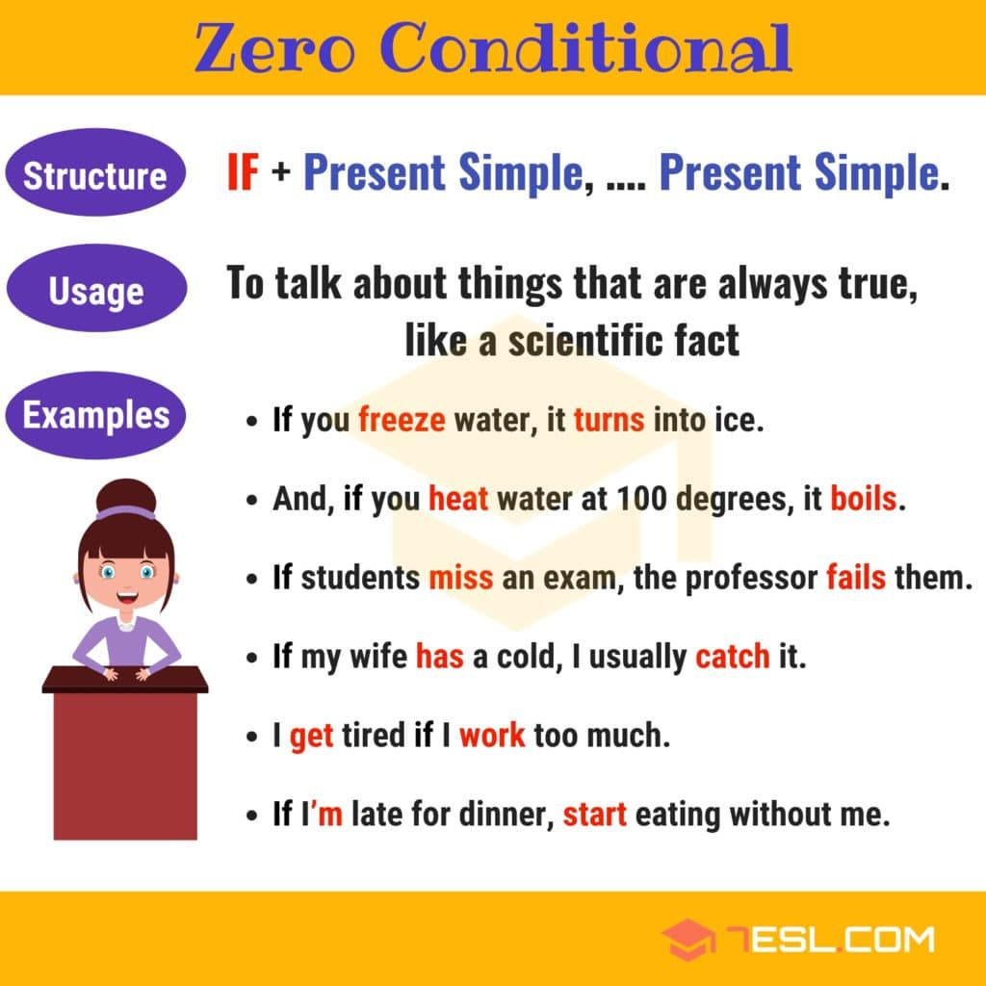
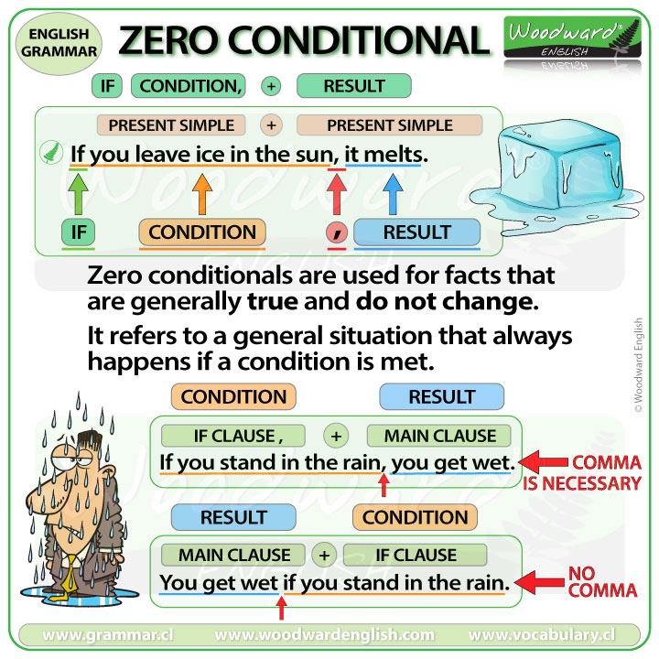

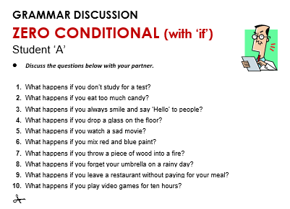
Practice.
 | conditions | result
si la gente come mucho-ellos engordan | If people eat too much, | they get fat.
si tocas el fuego, te quemas | If you touch a fire, | you get burn
si los bebes están con hambre, lloran | If babies are hungry, | they cry
si tu estudias, aprendes  si tu no estudias, no aprendes | If you study, | you learn
 | if she doesn’t wear an umbrella in a rainy days, | she gets wet

 | result | condition
si la gente come mucho-ellos engordan | they get fat | If people eat too much
si tocas el fuego, te quemas | you get burn | If you touch a fire
si los bebes están con hambre, lloran | they cry | If babies are hungry

Homework
Complete the sentence about zero conditional using the correct form of the verb.
1. If it doesn´t __rains_(rain) , plants cannot grow.
2. If I______ (try) to cook, I ruin the cook.
3. If you smoke, your skin ____(age) more quickly.
4. If my husband ____ (cook), he_______(burn) the food.
5. If children______(not/eat) well, they______(not/be) healthy.
6. Lots of people _____(come ) if Jenny _____(have) a party.
7. She _________ (buy) expensive clothes if she______(go) shopping.
8. If she_________ (work) hard, my daughter ______(pass) her exam.
9. If I ______(stay) at home, I ________(feel) sick.
10. If we __________(travel) around the world, we __________(take ) a lot of pictures.

