|  |  |  |
| --- | --- | --- |
|  | **UNIDAD EDUCATIVA “LUIS ROBERTO BRAVO”**  **CIUDADELA CATÓLICA. BARRIAL BLANCO Y ORDOÑEZ CRESPO.**  TELÉFONO 2341209  CUENCA-ECUADOR  Email: [lrbravo@hotmail.com](mailto:lrbravo@hotmail.com) | **School Year**  **2020 - 2021** |

|  |  |  |  |  |  |
| --- | --- | --- | --- | --- | --- |
| **Teacher:** | Lic. Ruth León | | | **Date:** |  |
| **Area** | Foreign Language | **Class** | **9th A morning** | **School Year** | 2020 - 2021 |
| **Subject.** | English | | | **Time** | week |
|  | **Activities** | | | | |
| **Topic:** SIMPLE PRESENT – PRESENT CONTINUOUS  Link to support you: <https://ruth-leon.webnode.es/>  **1. HOMEWORK**  NOTA: Realice las actividades solicitadas en lo que tenga a su disposición ( cuaderno, hojas perforadas) subir el deber al link que se encuentra a continuación.  <https://drive.google.com/drive/folders/1agxcz_jvaZw9dMyQevhJdXMo5inkt5Me?usp=sharing>  **Fecha de entrega: viernes 6 de noviembre del 2020**  **Fecha de recepción: martes 10 de noviembre del 2020.** | | | | | |

**PRESENT CONTINUOUS**

|  |  |  |
| --- | --- | --- |
| **verb to be** | **I (am)**  **she it he ( is)**  **we you they( are)** |  |
| **affirmative**  **I am teaching** | **negative**  **I am not teaching** | **interrogative**  **Am I teaching?** |

|  |  |  |  |
| --- | --- | --- | --- |
| Verb to be ( am- is – are ) | | | |
|  | AFFIRMATIVE | NEGATIVE | INTERROGATIVE |
| I / study at the moment | I am studying at the moment | I am not studying | Am I studying? |
| I / not / sleep | I am sleeping | I am not sleeping | Am I sleeping? |
| you / not  play badminton tonight | You are playing badminton tonight | You are not playing badminton tonight | Are you playing badminton tonight? |
| we / watch TV? | we are watching TV | we are not watching TV | Are we watching TV? |
|  |  |  |  |

|  |  |  |  |
| --- | --- | --- | --- |
| Verb to be ( am- is – are ) | | | |
|  | AFFIRMATIVE | NEGATIVE | INTERROGATIVE |
| 1) (he / not / wait for the bus) | he is waiting for the bus. | he is not (isn´t) waiting for the bus. | Is he waiting for the bus? |
| (we / study French) | We are studying French | We are not (aren´t)studying French | Are we studying French? |
| (they / cook) |  |  |  |
| (I / not / work in Spain) |  |  |  |
| (she / work in a restaurant now) |  |  |  |
| they/play/ soccer/ |  |  |  |
| you/ eat / candies / |  |  |  |

**HOMEWORK**

**Present continuous**

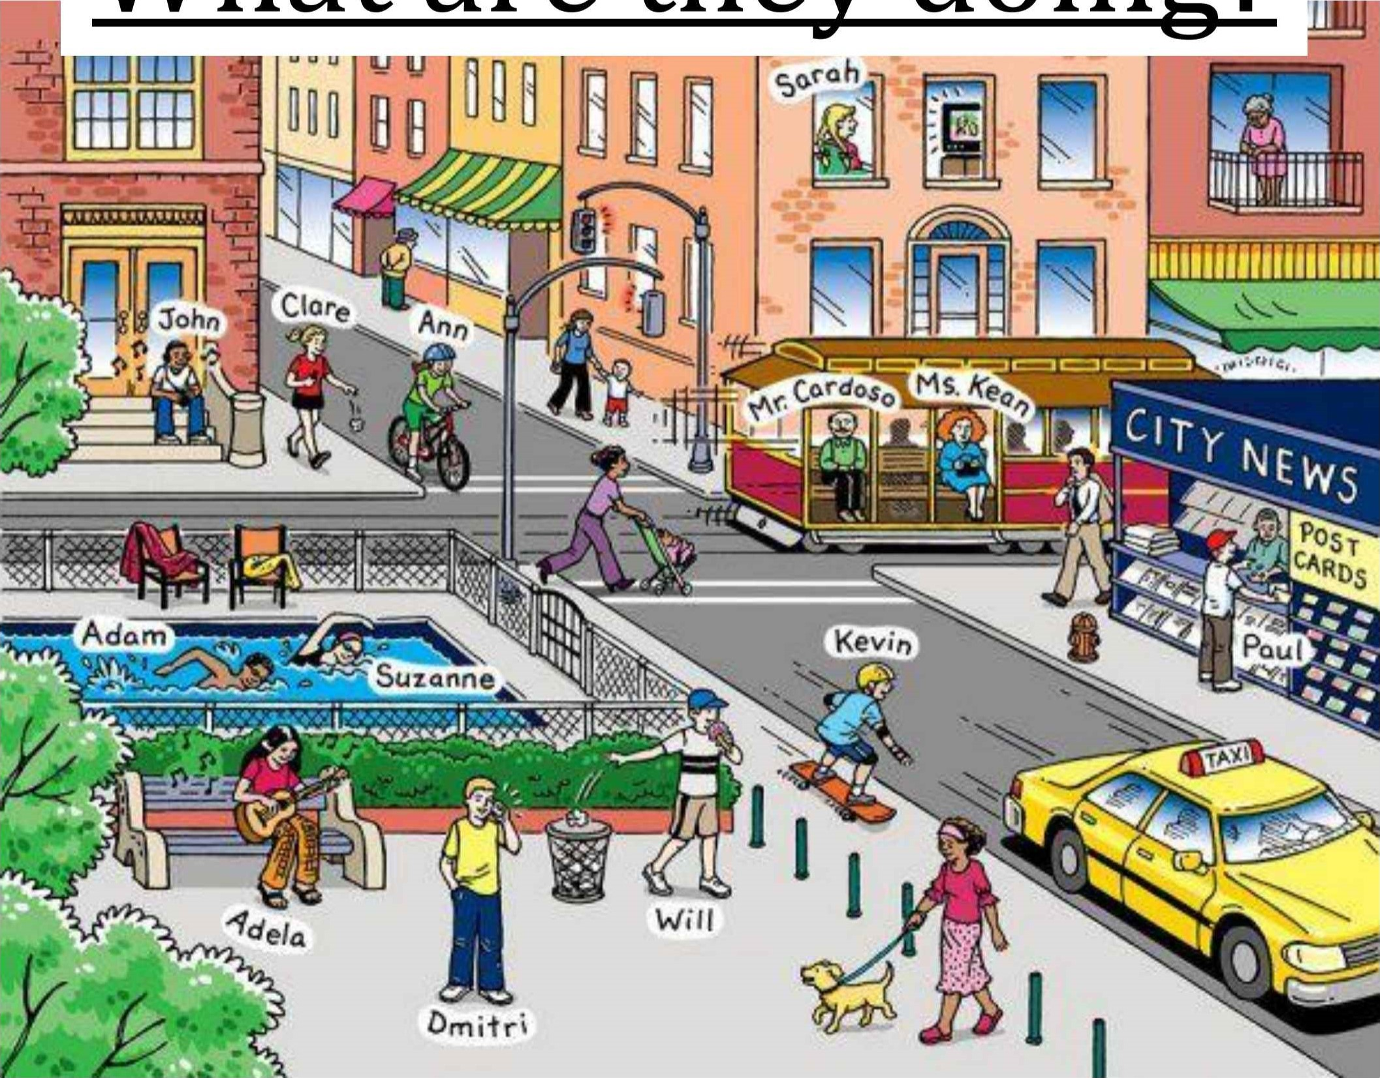What are they doing?

Look at the picture, then connect the people with their activities. ( no tiene que realizar el dibujo)

**Sarah is…**

**John is…**

**Clare is…**

**Ann is…**

**Mr. Cardoso and Ms. Kean are...**

**Paul is…**

**Adam and Suzanne are…**

**Adela is…**

**Dimitri is…**

**Will is…**

**Kevin is…**

|  |
| --- |
| ...playing with a small ball.  ...listening to music.  ...talking on the phone.  ...riding a bicycle.  ...riding on a skateboard ...watching TV.  ...having an ice-cream.  ...playing the guitar.  ...buying a newspaper.  ...swimming.  ...travelling on a tram. |

