|  |  |  |
| --- | --- | --- |
|  | **UNIDAD EDUCATIVA “LUIS ROBERTO BRAVO”**  **CIUDADELA CATÓLICA. BARRIAL BLANCO Y ORDOÑEZ CRESPO.**  TELÉFONO 2341209  CUENCA-ECUADOR  Email: [lrbravo@hotmail.com](mailto:lrbravo@hotmail.com) | **School Year**  **2020 - 2021** |

|  |  |  |  |  |  |
| --- | --- | --- | --- | --- | --- |
| **Teacher:** | Lic. Ruth León | | | **Date:** | OCTOBER |
| **Area** | Foreign Language | **Class** | **8th. A- B EGB** | **School Year** | 2020 - 2021 |
| **Subject.** | English | | | **Time** | week 10 |
|  | **Activities** | | | | |
| **1. Revisar la página** [**https://ruth-leon.webnode.es/english-8-a/**](https://ruth-leon.webnode.es/english-8-a/)  **2. TOPIC:** Yes/no questions Wh-questions**.**  **3. Do the exercises below follow the example.**  Note: Realice las actividades solicitadas en lo que tenga a su disposición (cuaderno, hojas perforadas) subir el deber al link que se encuentra a continuación dependiendo de su curso.  **Fecha de entrega: viernes 6 de noviembre del 2020**  **Fecha de recepción: martes 10 de noviembre del 2020**   |  |  | | --- | --- | | <https://drive.google.com/drive/folders/17lbo1R7JmwBGAx6H-uxGSpgU1NszVMrF?usp=sharing> | OCTAVO A | | <https://drive.google.com/drive/folders/1PkXN19cZTUNQ8u4uSy-X3V7epXC2tkjJ?usp=sharing> | OCTAVO B | | | | | | |

**WH**-**questions** are **questions** starting with **WH** or **h** words including: what, when, where, who, whom, which, whose, why and how, how much. **Question** words are used to ask about specific qualities, times, places, people and so on. Wh question cannot answer with Yes or No, due to these are informative.

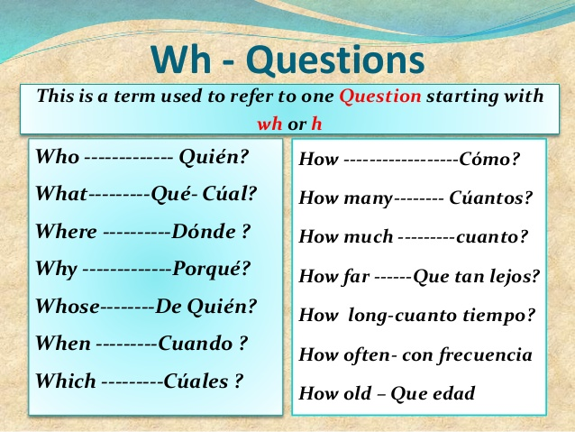

**Class activity**

WHO?



|  |  |  |  |
| --- | --- | --- | --- |
|  | Question | | Answer |
| 1 | what | IS YOUR NAME? | My name is Paul. |
| 2 | where | DO YOU LIVE? | I live in Cuenca |
| 3 |  | AREYOU DOING? | I'm doing my homework. |
| 4 |  | IS YOUR BOOK? | It's in my schoolbag. |
| 5 |  | IS THIS? | It's an apple |
| 6 |  | ARE YOU? | I'm at home. |
| 7 |  | IS YOUR BEST FRIEND? | My best friend is Mike. |
| 8 | who | IS YOUR FATHER? | My father is Raul |
| 9 | what | IS YOUR MOTHER'S NAME? | She is Elvia |
| 10 |  | TIME IS IT? | It's 10 0'clock. |
| 11 |  | IS YOUR TEACHER? | My teacher is Karina. |
| 12 |  | IS YOUR BIRTHDAY? | It's in April. |
| 13 |  | IS YOUR FAVOURITE FOOD? | My favourite food is . |
| 14 |  | IS THE ENGLISH CLASS? | It's on Monday and Wednesday. |
| 15 |  | IS YOUR FAVOURITE FOOTBALL PLAYER? | He's Cristiano Ronaldo. |

**HOMEWORK**

2) Now, go to your notebook, copy the date and answer the questions about you. Use words: what, where , who and when (Responda las preguntas con su información personal guíese en la actividad trabajada en clases.)

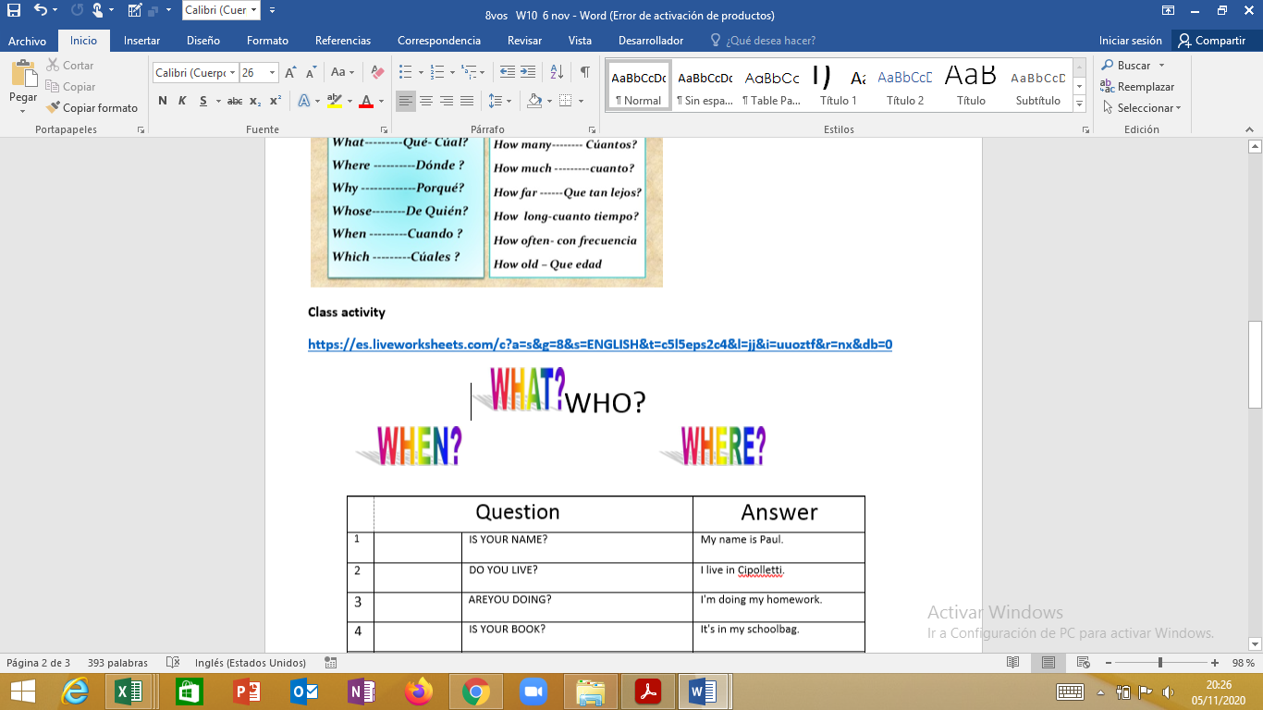

|  |  |  |  |
| --- | --- | --- | --- |
|  | Question | | Answer |
| 1 | WHAT | IS YOUR NAME? | My name is…. |
| 2 | WHERE | DO YOU LIVE? |  |
| 3 |  | AREYOU DOING? |  |
| 4 |  | IS YOUR BOOK? |  |
| 5 |  | IS THIS? |  |
| 6 |  | ARE YOU? |  |
| 7 | who | IS YOUR BEST FRIEND? | my best friend is …. |
| 8 |  | IS YOUR FATHER? |  |
| 9 | what | IS YOUR MOTHER'S NAME? | she is … |
| 10 |  | TIME IS IT? |  |
| 11 |  | IS YOUR TEACHER? |  |
| 12 |  | IS YOUR BIRTHDAY? | it´s in … |
| 13 |  | IS YOUR FAVOURITE FOOD? |  |
| 14 |  | IS THE ENGLISH CLASS? |  |
| 15 |  | IS YOUR FAVOURITE FOOTBALL PLAYER? |  |