 | UNIDAD EDUCATIVA “LUIS ROBERTO BRAVO”  CIUDADELA CATÓLICA. BARRIAL BLANCO Y ORDOÑEZ CRESPO.  TELÉFONO 2341209  CUENCA-ECUADOR  Email: lrbravo@hotmail.com | School Year  2020 - 2021
Teacher: | Lic. Ruth León |  |  | Date: | October- 2020
Area | Foreign Language | Class | 10th A morning | School Year | 2020 - 2021
Subject. | English |  |  | Time | week
Activities
TOPIC: Prepositions in – on- at.
Realice las actividades solicitadas en lo que tenga a su disposición (cuaderno, hojas perforadas) subir al link que se encuentra a continuación; cada tarea debe tener: título, nombre del estudiante, curso, fecha y firma del representante.

https://drive.google.com/drive/folders/10-ywowW8UPeTqGhAKMGP-6ILTU6ZEl-m?usp=sharing

Fecha de entrega: viernes 30 de octubre del 2020
Fecha de recepción: martes 3 de noviembre del 2020

Prepositions of Time - at, in, on
We use:
- at for a PRECISE TIME
- in for MONTHS, YEARS, CENTURIES and LONG PERIODS
- on for DAYS and DATES

at for a PRECISE TIME | in for MONTHS, YEARS, CENTURIES and LONG PERIODS | on for DAYS and DATES
at the moment | in the morning
at 3 o'clock | in May | on Sunday
at 10.30am | in summer | on Tuesdays
at noon | in the summer | on 6 March
at dinnertime | in 1990 | on 25 Dec. 2010
at bedtime | in the 1990s | on Christmas Day
at sunrise | in the next century | on Independence Day

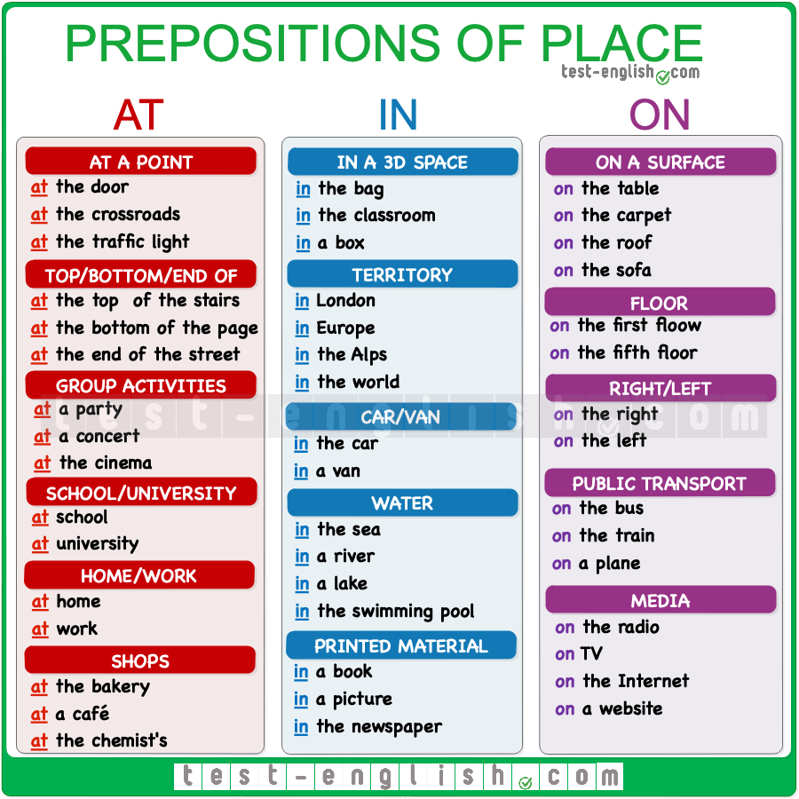
Practice:
1. Choose the correct prepositions:
1. "Let's meet ____at___ midday ____on___ Saturday."
2. "You won't be working ___on____ Saturday nights ____in___ the future, will you?"
3. I'm busy ___at the moment, but I'll be free ___in the ___ evening."

HOMEWORK
Write the correct prepositions of time in- on-at
1. ____________ September
2. ____________12 o´clock
3. ____________ winter
4. _____________Easter Monday
5. _______________4th July, 1776
6. ____________Christmas
7.______________Tuesday
8. ______________ the weekend
9. ____________ my birthday
10._______________ the end of the week
11. Lucy is arriving _____February the 13th _____eight o'clock _____the morning.
12. The class is ____9am ______Monday mornings.

