|  |  |  |
| --- | --- | --- |
|  | **UNIDAD EDUCATIVA “LUIS ROBERTO BRAVO”**  **CIUDADELA CATÓLICA. BARRIAL BLANCO Y ORDOÑEZ CRESPO.**  TELÉFONO 2341209  CUENCA-ECUADOR  Email: [lrbravo@hotmail.com](mailto:lrbravo@hotmail.com) | **School Year**  **2020 - 2021** |

|  |  |  |  |  |  |
| --- | --- | --- | --- | --- | --- |
| **Teacher:** | Lic. Ruth León | | | **Date:** |  |
| **Area** | Foreign Language | **Class** | **9th A morning** | **School Year** | 2020 - 2021 |
| **Subject.** | English | | | **Time** | week |
|  | **Activities** | | | | |
| **Topic:** SIMPLE PRESENT – PRESENT CONTINUOUS  Link to support you: <https://ruth-leon.webnode.es/>  **1. HOMEWORK**  NOTA: Realice las actividades solicitadas en lo que tenga a su disposición ( cuaderno, hojas perforadas) subir el deber al link que se encuentra a continuación.  <https://drive.google.com/drive/folders/1pwtGxfzy8Ld1n7cgZuSnijWyMPF1OM86?usp=sharing>  **Fecha de entrega: viernes 30 octubre del 2020**  **Fecha de recepción: martes 3 de noviembre del 2020.** | | | | | |

**SIMPLE PRESENT – PRESENT CONTINUOUS**

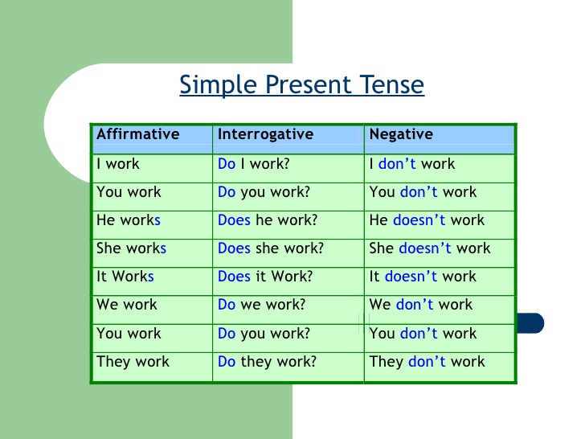

|  |  |
| --- | --- |
| **I-YOU – WE – YOU- THEY** | **INFINITIVE VERBS** |
| **HE – SHE- IT** | **VERBS IES- ES –S** |
| **she – it-he** | **does – doesn´t** |
| **we- they- you- I - you** | **do** |

|  |  |  |
| --- | --- | --- |
| AFFIRMATIVE | NEGATIVE ( do –does) | INTERROGATIVE ( do- does) |
| She plays tennis | she doesn´t play tennis. | Does she play tennis? Yes, she does/ No, she doesn´t |
| we play soccer. | We don´t play soccer | Do we play soccer? |
| They eat chocolates. | they don´t eat chocolates. | Do they eat chocolates? |
| She listens to music. | She doesn´t listen to music. | Does she listen to music? |

**PRESENT CONTINUOUS**

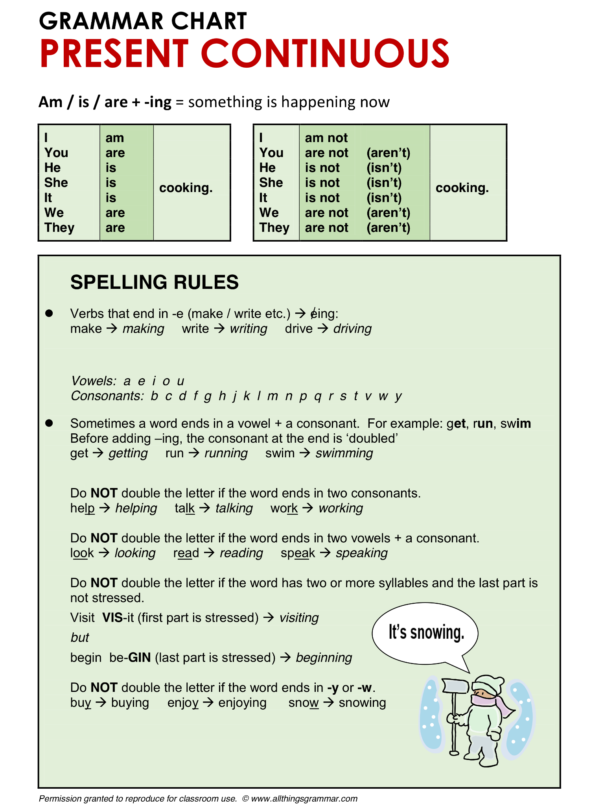

**PRACTICE**

|  |  |  |
| --- | --- | --- |
| **verb to be** | **I (am)**  **she it he ( is)**  **we you they( are)** |  |
| **affirmative**  **I am teaching** | **negative**  **I am not teaching** | **interrogative**  **Am I teaching?** |

|  |  |  |  |
| --- | --- | --- | --- |
| Verb to be ( am- is – are ) | | | |
|  | AFFIRMATIVE | NEGATIVE | INTERROGATIVE |
| I / study at the moment | I am studying | I am not studying | Am I stuadying? |
| I / not / sleep | I am sleeping | I am not sleeping | Am I sleeping? |
| you / not  play badminton tonight | You are playing badminton tonight | You are not playing badminton tonight | Are you playing badminton tonight? |
| we / watch TV? | we are watching TV | we are not watching TV | Are we watching TV? |

**HOMEWORK**

Make the present continuous, positive, negative or questions use am – is – are + ing form

1. She / not / work in Spain _____________________________

2. We / not / go to the cinema tonight _________________________________

3. They / read _______________________________________

4. She / eat chocolate?__________Is she eating chocolates?_______________________

5. I / not / live in Paris_________________________________

6. They / live in London ________________________________

7. He / walk to school now? _____________________________

8. It / sit/ under the table ________________________________

9. You/ play /in the park_________________________________

10. We / write/ a letter __________________________________