|  |  |  |
| --- | --- | --- |
|  | **UNIDAD EDUCATIVA “LUIS ROBERTO BRAVO”**  **CIUDADELA CATÓLICA. BARRIAL BLANCO Y ORDOÑEZ CRESPO.**  TELÉFONO 2341209  CUENCA-ECUADOR  Email: [lrbravo@hotmail.com](mailto:lrbravo@hotmail.com) | **School Year**  **2020 - 2021** |

|  |  |  |  |  |  |
| --- | --- | --- | --- | --- | --- |
| **Teacher:** | Lic. Ruth León | | | **Date:** | OCTOBER |
| **Area** | Foreign Language | **Class** | **8th. A- B EGB** | **School Year** | 2020 - 2021 |
| **Subject.** | English | | | **Time** | week |
|  | **Activities** | | | | |
| **1. Revisar la página** [**https://ruth-leon.webnode.es/english-8-a/**](https://ruth-leon.webnode.es/english-8-a/)  **2. TOPIC:** Yes/no questions Wh-questions**.**  **3. Copy the information.**  **4. Do the exercises below follow the example.**  Note: Realice las actividades solicitadas en lo que tenga a su disposición (cuaderno, hojas perforadas) subir el deber al link que se encuentra a continuación dependiendo de su curso.  **Fecha de entrega: viernes 30 de octubre del 2020**  **Fecha de recepción: martes 3 de noviembre del 2020**   |  |  | | --- | --- | | <https://drive.google.com/drive/folders/1ukMB_WaMAWe9Q4UHI_mNwMfg3lXxRyJm?usp=sharing> | OCTAVO A | | <https://drive.google.com/drive/folders/1dKOSnOvhovmtVZaeEbcdF8kugBKbNPvz?usp=sharing> | OCTAVO B | | | | | | |

**EXPLANATION**

|  |  |
| --- | --- |
| Yes/no questions Wh-questions | |
| **Wh**ere are you from? | I´m from Ecuador |
| **Wh**at’s your teacher’s nationality? | She´s Ecuadorian  He´s…………… |
| **Wh**at´s your favorite sport? | My favorite sport is basketball |

**WH**-**questions** are **questions** starting with **WH** or **h** words including: what, when, where, who, whom, which, whose, why and how, how much. **Question** words are used to ask about specific qualities, times, places, people and so on. Wh question cannot answer with Yes or No, due to these are informative.

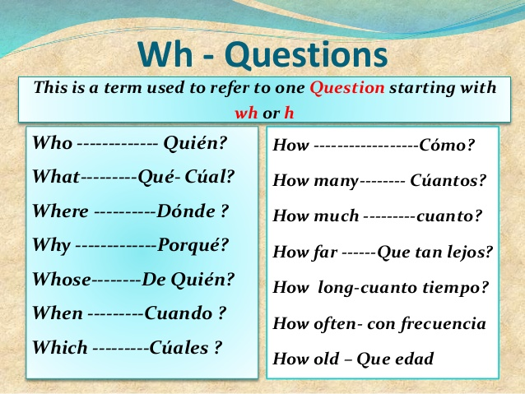

**PRACTICE**

|  |  |  |
| --- | --- | --- |
| **What - Where - When - Why - Which - How** | | |
| What | are you doing? | I´m playing |
| When  Where | is your birthday?  is your birthday? | it´s next week.  it´s in my house. |
| Who | Is that girl? | she is my sister |
| Why | are you don’t go to the school these days? | because I´m sick. |
| Where | are you from? | I´m from Ecuador |
| How | are you feeling today? | I feel good |
| Which | one do you prefer? | I prefer the yellow color |

**HOMEWORK**

**MATCH THE QUESTIONS WITH ANSWERS.**

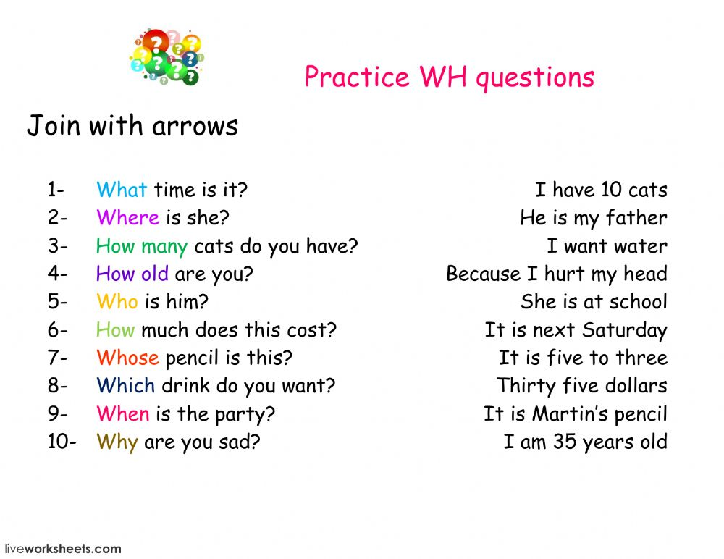

My name is Kenzo. I am from Japan. I am Japanese.