|  |  |  |
| --- | --- | --- |
|  | **UNIDAD EDUCATIVA “LUIS ROBERTO BRAVO”**  **CIUDADELA CATÓLICA. BARRIAL BLANCO Y ORDOÑEZ CRESPO.**  TELÉFONO 2341209  CUENCA-ECUADOR  Email: [lrbravo@hotmail.com](mailto:lrbravo@hotmail.com) | **School Year**  **2020 - 2021** |

|  |  |  |  |  |  |
| --- | --- | --- | --- | --- | --- |
| **Teacher:** | Lic. Ruth León | | | **Date:** |  |
| **Area** | Foreign Language | **Class** | **1st BGU morning** | **School Year** | 2020 - 2021 |
| **Subject.** | English | | | **Time** | week |
| **Skills and performance criteria**  **Activities** | | | | | |
| **TOPIC. Future Simple**  Note: Realice las actividades solicitadas en lo que tenga a su disposición (cuaderno, hojas perforadas) subir al link que se adjunta a continuación; cada tarea debe tener: título, nombre del estudiante, curso, fecha y firma del representante. Presentar a tiempo sus actividades.  <https://drive.google.com/drive/folders/1J2cuxVvvaZjjJIcFjwIX6g_t2KVBLt9F?usp=sharing>  **Fecha de recepción: miércoles 28 de octubre del 2020.** | | | | | |

**FUTURE SIMPLE**

<https://www.youtube.com/watch?v=vjoZvhzWfxI>

We use future simple:

to predict future events

to express promises

to make spontaneous or quick decisions

to talk about coming events

GRAMMAR STRUCTURE

|  |  |  |
| --- | --- | --- |
| AFFIRMATIVE | NEGATIVE | QUESTION |
| S- WILL-verb- complement  you will visit your mother | S + will+ not+ verb+ complement  you will not visit your mother | Will+ you+ verb + complement  will you visit your mother? |

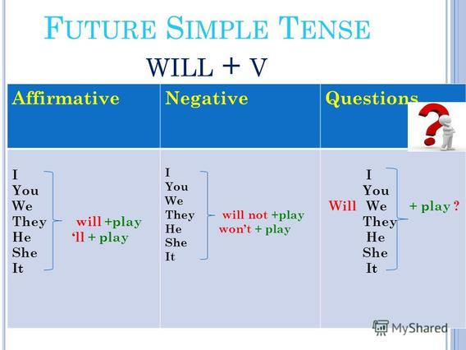

**PRACTICE:**

|  |  |  |
| --- | --- | --- |
| AFFIRMATIVE | NEGATIVE | QUESTION |
| You will dance on Saturday. | you will not dance on Saturday. | Will you dance on Saturday? |
| She will travel next week. | She won´t travel next week. | Will she travel next week? |
| They will read a book. | They will not ( won´t) write a book. | will they write a book? |
| We will eat pizza. | We won´t eat pizza. | Will we eat pizza. |

**HOMEWORK:**

**WILL EXERCISES**

**1.** Complete the sentences with **will** in **positive form**:

a) If I arrive late, I (call) ______will call _________ you.

b) They (help) _______________ you.

c) Maybe he (stay) _______________ at home tonight.

d) My friends (go/probably) _______________ to the beach.

e) Peter (buy) _______________ the tickets.

f) I hope that my boyfriend (cook) _______________ dinner tonight.

g) We think FCB (win) _______________ the match.

h) I’m sure my boss (understand) _______________ my problem.

i) I (get) _______________ you a drink. Do you like coffee?

j) Maybe my sister (do) _______________ a language course in London.

**2.** Complete the sentences with **will** in **negative form**:

a) I (answer) __ won´t answer____________ the question.

b) My brother (lock) _______________ the door.

c) The boy (catch) _______________ the ball.

d) I (read) _______________ that magazine.

e) We (send) _______________ that present to my uncle.

f) My grandmother (open) _______________ the door.

g) The children (eat) _______________ fish.

h) He (listen) _______________ to the radio.

i) I (drink) _______________ beer.

j) It (rain) _______________.

**3.** Complete the sentences with **will** in interrogative form:

a) (you / go / to the party) ______will you go to the party_________ ?

b) (James / open / the window) __________________________________________ ?

c) (your mother / cook / a cake) __________________________________________ ?

d) (she / get / married) __________________________________________ ?

e) (you / help / me / with my homework) __________________________________________ ?

f) (What / we / eat) __________________________________________ ?

g) (When / Megan / be / famous) _____When will Megan be famous____ ?

h) (they/ visit/ their grandparents) __________________________________________ ?

i) (we / meet /Rihanna) __________________________________________ ?

j) (I / earn/ lots of money) __________________________________________ ?