 | UNIDAD EDUCATIVA “LUIS ROBERTO BRAVO”  CIUDADELA CATÓLICA. BARRIAL BLANCO Y ORDOÑEZ CRESPO.  TELÉFONO 2341209  CUENCA-ECUADOR  Email: lrbravo@hotmail.com | School Year  2020 - 2021
Teacher: | Lic. Ruth León |  |  | Date: | October- 2020
Area | Foreign Language | Class | 10th A morning | School Year | 2020 - 2021
Subject. | English |  |  | Time | week
Activities
TOPIC: SPORTS
a) ANSWER THE FOLLOWING QUESTIONS
1. What is important when you play on a team?
2. Do you think that uniforms are important? Why?
b) Read the paragraph.
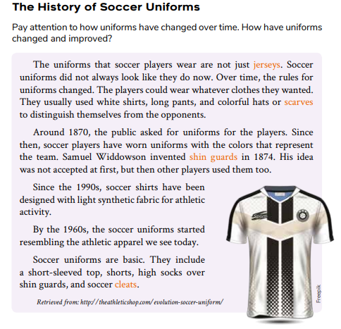
c) After Reading
4. circle the verbs in past form.
5. How have soccer uniforms changed throughout history?
6. Do you think that soccer uniforms can be still improved? Why? Would you change anything?
7. Compare and contrast the uniforms of 2 teams. Is one better than the other? Why?

Realice las actividades solicitadas en lo que tenga a su disposición (cuaderno, hojas perforadas) subir al link que se encuentra a continuación; cada tarea debe tener: título, nombre del estudiante, curso, fecha y firma del representante.
https://drive.google.com/drive/folders/1wYrfjBvHqXNQwvwe7gnk5MGt0t_pJOHz?usp=sharing
Fecha de entrega: viernes 23 de octubre del 2020
Fecha de recepción: martes 27 de octubre del 2020

