 | UNIDAD EDUCATIVA “LUIS ROBERTO BRAVO”  CIUDADELA CATÓLICA. BARRIAL BLANCO Y ORDOÑEZ CRESPO.  TELÉFONO 2341209  CUENCA-ECUADOR  Email: lrbravo@hotmail.com | School Year  2020 - 2021
Teacher: | Lic. Ruth León |  |  | Date:
Area | Foreign Language | Class | 9th A morning | School Year | 2020 - 2021
Subject. | English |  |  | Time | week
 | Activities
Topic: Types of music
Link to support you: https://ruth-leon.webnode.es/
1. HOMEWORK
How do you feel before an exam? Stressed, relaxed, confident?
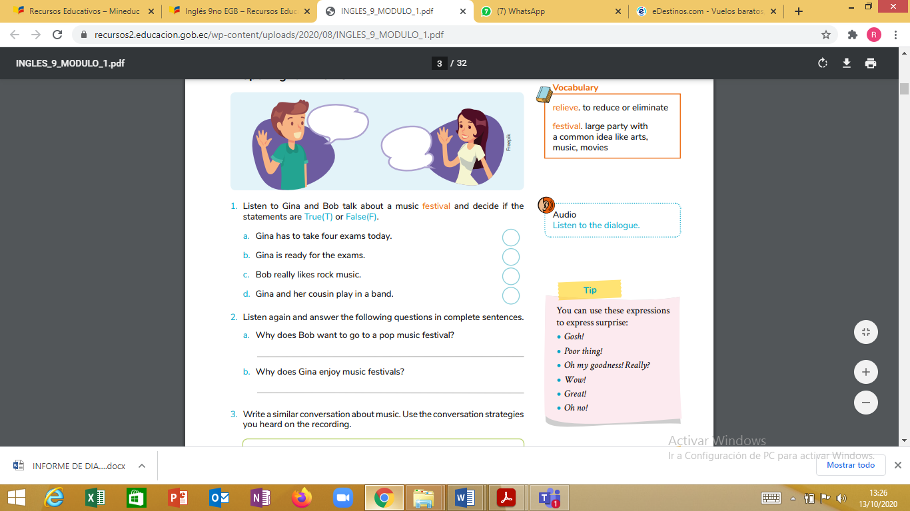
1. Listen to Gina and Bob talk about a music festival and decide if the statements are True(T) or False(F).
a. Gina has to take four exams today.
b. Gina is ready for the exams.
c. Bob really likes rock music.
d. Gina and her cousin play in a band.

2. Listen again and answer the following questions in complete sentences.
a. Why does Bob want to go to a pop music festival? ______________________
b. Why does Gina enjoy music festivals? _________________________

NOTA: Realice las actividades solicitadas en lo que tenga a su disposición ( cuaderno, hojas perforadas) subir el deber al link que se encuentra a continuación.
https://drive.google.com/drive/folders/1a6-FBA8zL-aH2BSOHQbqlxRpGvI_9ahh?usp=sharing

Fecha de entrega: viernes 23 octubre del 2020
Fecha de recepción: martes 27 de octubre

