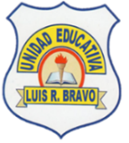 | UNIDAD EDUCATIVA “LUIS ROBERTO BRAVO”  CIUDADELA CATÓLICA. BARRIAL BLANCO Y ORDOÑEZ CRESPO.  TELÉFONO 2341209  CUENCA-ECUADOR  Email: lrbravo@hotmail.com | School Year  2020 - 2021
Teacher: | Lic. Ruth León |  |  | Date: | OCTOBER
Area | Foreign Language | Class | 2ND BGU MORNING | School Year | 2020 - 2021
Subject. | English |  |  | Time | week
 | Activities
Topic: Were are you from?
1. Answer the questions.
Where are you from?
And your parents?
And your grandparents?

2. Reading
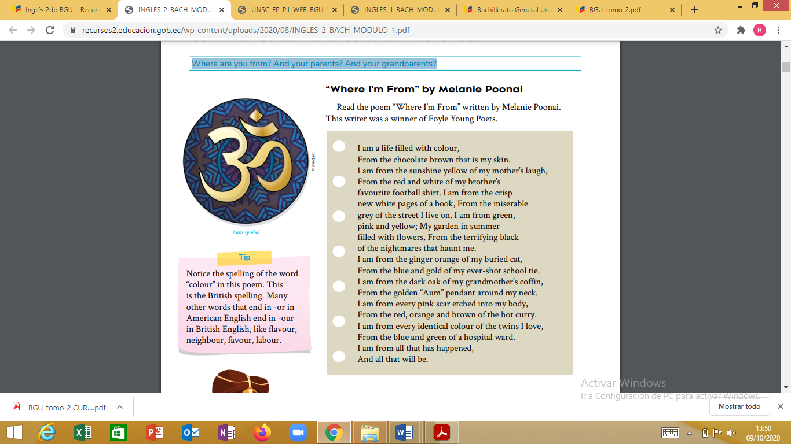

3. Answer the following questions from the poem considering that Melanie Poonai is the main character.
a. Where does she live? ___________________________
b. What does she look like? _________________________
c. Is her cat alive? ________________________________
d. What is her brother’s favorite sport? ________________
e. Is her mother alive? _____________________________
f. Can you deduce where she is from? _________________
g. Write down all the family members she mentions in this poem. ______________________________

Note: Realizar las actividades solicitadas en lo que tenga a su disposición ( cuaderno, hojas perforadas)
Subir el deber al link que se encuentra en la página Webnode.
Fecha de recepción: miércoles 14 de octubre

