 | UNIDAD EDUCATIVA “LUIS ROBERTO BRAVO”  CIUDADELA CATÓLICA. BARRIAL BLANCO Y ORDOÑEZ CRESPO.  TELÉFONO 2341209  CUENCA-ECUADOR  Email: lrbravo@hotmail.com | School Year  2020 - 2021
Teacher: | Lic. Ruth León |  |  | Date:
Area | Foreign Language | Class | 1st BGU morning | School Year | 2020 - 2021
Subject. | English |  |  | Time | week
Skills and performance criteria
Activities
TOPIC. Environmental issues
1. BEFORE READING
- What are the main problems that the world faces in terms of environmental issues?
- Write 5 of them and underline the 2 that need to be solved most urgently.

2. Read the following passage.

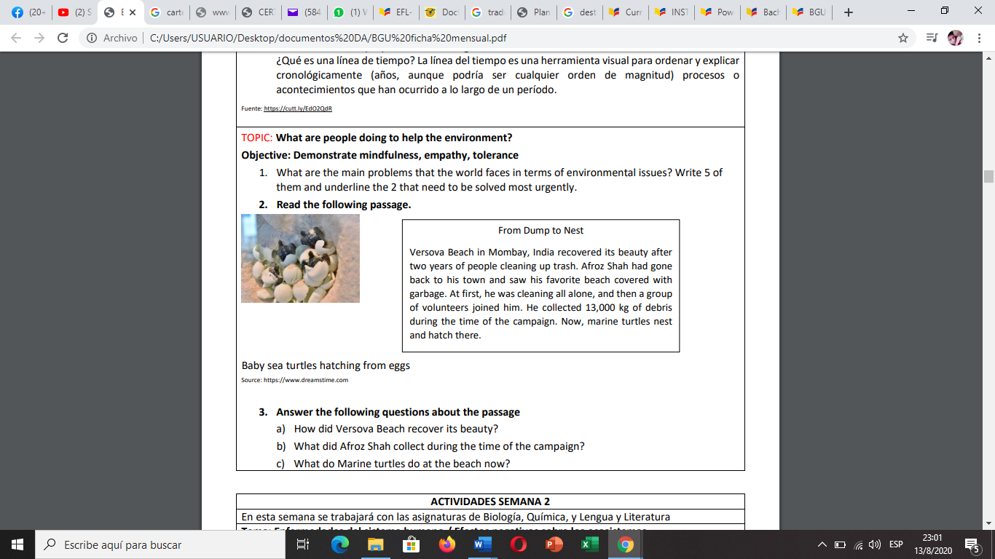
3. Answer the following questions about the passage
a) How did Versova Beach recover its beauty?
b) What did Afroz Shah collect during the time of the campaign?
c) What do Marine turtles do at the beach now?

Note: Realice las actividades solicitadas en lo que tenga a su disposición (cuaderno, hojas perforadas) subir al link que se adjunta en la pagina de webnode, cada tarea debe tener: título, nombre del estudiante, curso, fecha y firma del representante. Presentar a tiempo sus actividades
Fecha de recepción: miércoles 14 de octubre del 2020.

