 | UNIDAD EDUCATIVA “LUIS ROBERTO BRAVO”  CIUDADELA CATÓLICA. BARRIAL BLANCO Y ORDOÑEZ CRESPO.  TELÉFONO 2341209  CUENCA-ECUADOR  Email: lrbravo@hotmail.com | School Year  2020 - 2021
Teacher: | Lic. Ruth León |  |  | Date: | 08-09- 2020
Area | Foreign Language | Class | 10th A morning | School Year | 2020 - 2021
Subject. | English |  |  | Time | week
Skills and performance criteria | Activities
EFL 4.2.1 Understand phrases and expressions related to areas of most immediate priority within the personal and educational domains, provided speech is clearly and slowly articulated.  (Example: daily life, free time, school activities, etc.) | Topic: Simple past, Past continuous  D. Fill in the blanks using simple past:  A: Where ______ (do) you go  Yesterday?  B: I ________ (go) to the park. I ______ (take) my dog for a walk. What ______ (do)you do last night?  A: I ________ (take) the bus to the stadium. I _______(see) the soccer game between the Lions and the Blue-wings. It ______ (be)a great game.  B: I _______(forget) about the game. Who _____ (win) the game?  A: The Lions _____(won) the game.  Link to support you: https://ruth-leon.webnode.es/  1. REVIEW  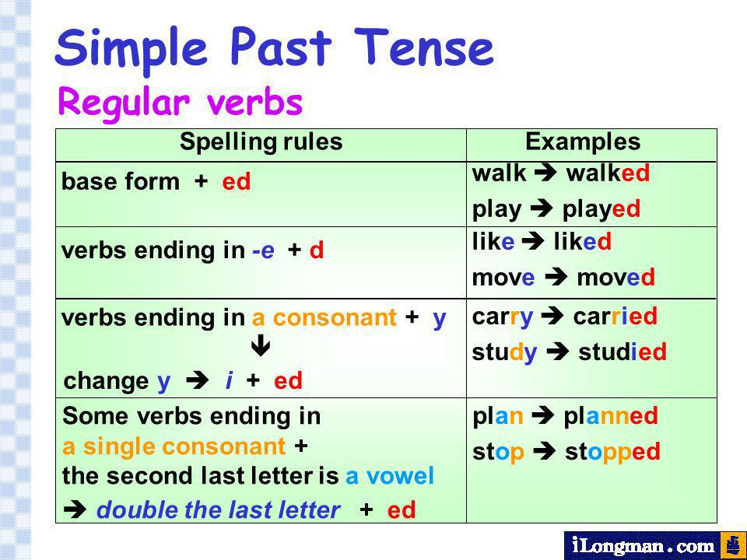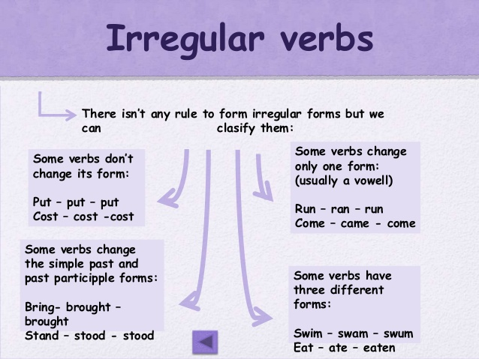  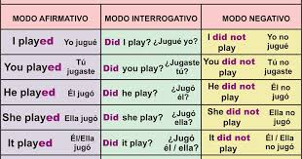  1.1 Copiar la materia de la imagen que está debajo a un cuaderno u hojas (divida el cuaderno mitad para deberes y mitad para materia hacer lo mismo si trabaja en hojas)  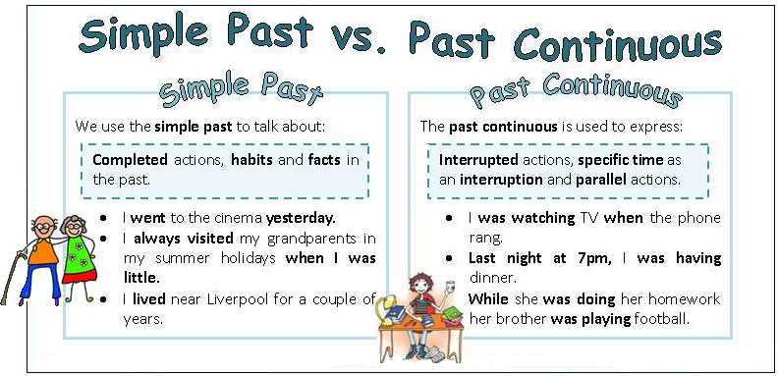  2. PRACTICE NO COPIAR  Verb to be / is(she –he –it)- am(I) –are ( we- you-they)  was (I- she-it –he)  were (we- you they) we were waiting for the class  - Fill in the blanks with “was” or “were”.  - Jane ___was__ doing homework.  - We____were___ eating cookies.  - The dog __was__ barking.  - Mom ____was____ cooking dinner.  - The boys __were___ playing baseball  - Dad __was____ watching TV.  - It ____ raining outside.  - The baby ____ crying.  - The girls _____ listening to music.  - I _____ taking a photo.  - They ______ running.  - You ______studying at home.  Fill in the blanks using simple past:  A: Where __DID____ (do) you go  Yesterday?  B: I __WENT______ (go) to the park. I ___TOOK___ (take) my dog for a walk. What ___DID___ (do)you do last night?  A: I ___TOOK____ (take) the bus to the stadium.  I ___SAW____(see) the soccer game between the Lions and the Blue-wings. It ____WAS__ (be)a great game.  B: I __FORGOT _____(forget) about the game. Who __WON___ (win) the game?  A: The Lions _____(won) the game.  HOMEWORK  Complete the sentences using past continuous  1.John ___was drinking________ coffee (drink) .  2.They ______were reading______ (read).  3.We ___were hunting_______ for Easter eggs (hunt).  4.Mom _____________ (exercise).  5. I ____________ Easter eggs (paint).  6.The children _________ TV (watch).  7.You ______________ to Kate (talk).  8.The dog _____________ the cat (chase).  9.The cat ________________ (run).  10.It _____________ outside(snow).  Rewrite the sentences both in the negative and interrogative forms. Past simple  Note: Realice las actividades solicitadas en lo que tenga a su disposición (cuaderno, hojas perforadas) enviar solo al WhatsApp personal 0989067393; cada tarea debe tener: título, nombre del estudiante, curso, fecha y firma del representante. Presentar a tiempo sus actividades  Fecha de entrega: viernes 18 de septiembre del 2020  Fecha de recepción: martes 22 de septiembre del 2020 hasta las 13h00
  - I walked to school.  NEG. I DID NOT WALK TO SCOOL  INT. DID I WALK TO SCHOOL  The car stopped at the traffic lights.  NEG. ___________________________  INT. ___________________________  - The boys played chess.  NEG. ___________________________  INT. ___________________________ | - I talked to Andrew.  NEG. ___________________________  INT. ___________________________  - Michael worked till late.  NEG. ___________________________  INT. ___________________________  - The baby cried all night.  NEG. ___________________________  INT. ___________________________

